Questions Bank

- What do you understand pulse dispersion? Discuss the role of primary line constants in pulse dispersion.
- List advantages and disadvantages of digital modulation communication systems.
- List various steps in pulse code modulation.
- Discuss the problems associated with quantization.
- What do you understand by BER? Discuss probability of error.
- What is a Pseudo-Random Code?
- List various error detection and correction code.
- State True or False and Justify:
PCM is a digital modulation technique.
- What do you mean by band rate?
- Discuss the difference between band rate and bit rate.
- What is the difference between coherent & non-coherent digital modulation techniques.
- Give the expression for ASK modulated signal.
- Is ASK a digital modulated signal? Justify your answer.
- Draw signal space diagram of ASK.
- Draw PSD for ASK signal.
- What is BER for ASK?
- Explain the concept of non-coherent binary ASK.
- For coherent ASK, the error probability is given by:
(a) (b)
(c) (d)
- _________ is most affected by noise
(a) PSK (b) ASK (c) FSK (d) DPSK
- Sketch the ASK waveform signal for input binary sequence 1100100010.
- Give atleast five systems that have TDM. System must be from some existing applications.
- To multiplex three signals which digital equipment is required & give its analog counter part also.
- How sampling process supports multiplexing?
- Draw the waveforms of a TDM-PCM systems.
- What is the basic/smallest circuit for sampling.
- What is the difference between TDM & FDM technique?
- What do you mean by synchronization in TDM-PCM signal?
- Why TDM is required? State its advantages and disadvantages.
- The bandpass signal is represented as a combinations ______ & ______.
- Give B/D for PCM receiver.
- Compare analog modulation system with digital modulation system.
- What do you mean by two tone FSK.
- Which system is better among ASK, PSK & FSK and why?
- Give the mathematical equation for FSK system.
- Give IC No. of FSK modulator and demodulator.
- Give the waveforms of modulating signal, carrier signal & FSK modulated signal.
- What do you understand by coherent and non-coherent FSK detection?
- What is fast frequency shift key? Discuss.
- What is continuous – phase FSK CP-FSK?
- Give the practical application of FSK system.
- What is a linearly polarized mode?
- State the necessity of cladding for an optical fiber.
- Relate the mode‐field diameter and spot size .
- Outline any four advantages of an optical communication system
- What is meant by Conical Half angle?
- Relate a formula for the normalized frequency and NA. Hence, find the Numerical aperture for a step index fiber that has normalized frequency V=26.6 at a 1300nm wavelength and core radius of 25µm.
- Apply the ray transmission theory to find the critical incident angle for a glass rod of refractive index 1.5, surrounded by air.
- With the knowledge of the total internal reflection, calculate the critical angle of incidence between two substances with different refractive indices where n1 = 1.5 and n2 = 1.46.
- Sort out the fundamental parameter of a single mode fiber .
- List out the advantages of the multimode fiber.
- Distinguish Step index fibers and graded index fiber
- Evaluate the critical angle with the relative refractive index difference of 1% for an optical fiber. Given the core refractive index
- Determine the cutoff wavelength of a single mode fiber with core radius of 4µm and ∆ = 0.003.
- The refractive indexes of the core and cladding of a silica fiber are 1.48 and 1.46 respectively. Find the acceptance angle for the fiber. Propose a suggestion to increase the acceptance angle of optical fiber.
- Formulate the normalized frequency at 820 nm for a step index fiber having a 25µm radius. The refractive indexes of the cladding and the core are 1.45 and 1.47 respectively. Solve to find the number of modes that propagate in this fiber at 820 nm?

Questions on Amplitude Modulation based on Gates/IES/PSU Exams

- In commercial TV transmission in India, picture and speech signals are modulated respectively
(Picture) |  |  | (Speech)
(a)VSB |  | and | VSB
(b)VSB |  | and | SSB
(c)VSB |  | and | FM
(d)FM |  | and | VSB

Soln. VSB modulation is the compromise between SSB and DSB. Since TV bandwidth is large so VSB is used for picture transmission. Also, FM is the best option for speech because of better noise immunity.
Option (c)

- In a double side-band (DSB) full carrier AM transmission system, if the modulation index is doubled, then the ratio of total sideband power to the carrier power increases by a factor of ____________.

Soln. The AM system is Double side band (DSB) with full carrier. The expression for total power in such modulation signal is

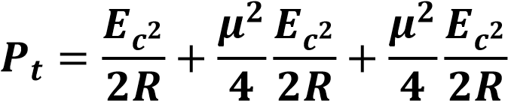

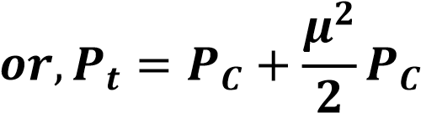
The second term on the right hand side is side band power.

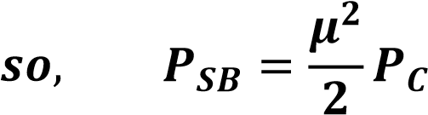

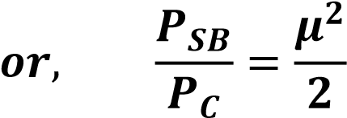
if µ (modulation index) is doubled then 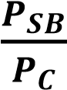will be 4 times
So, it is factor of 4
Ans. Factor of 4

- The maximum power efficiency of an AM modulator is
  - 25% (c)33%
  - 50% (d)100%

Soln. Efficiency of modulation can be given as

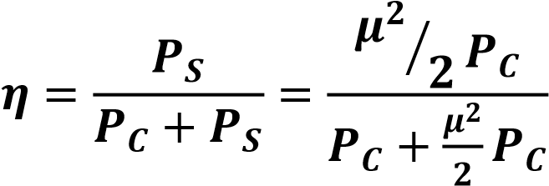

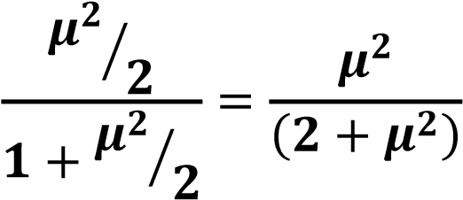
µ=1 is the optimum value
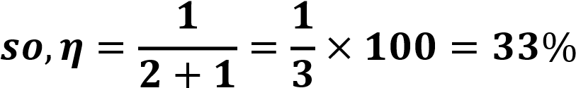
Option (c)

- Consider sinusoidal modulation in an AM systems. Assuming no over modulation , the modulation index (µ) when the maximum and minimum
values of the envelope, respectively, are 3V and 1V is ____________

Soln. There is no over modulation means that modulation index is less than or equal to 1.
In such case the formula for modulation index is given by

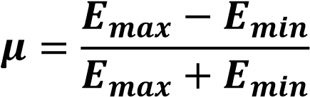
Where E_{max} is the maximum value of the envelope E_{min} is the minimum value of the envelope.
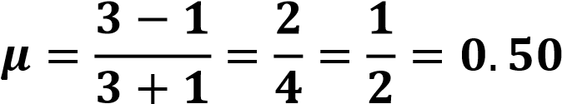
Modulation index is 0.50

- Which of the following analog modulation scheme requires the minimum transmitted power and minimum channel band-width?
  - VSB (c)SSB
  - DSB-SC (d)AM

Soln. Modulation type BW Power
Conventional AM 2 f_{m} Maximum power
DSB SC 2 f_{m} (Less power)
VSB f_{m} + vestige
SSB f_{m} Less & power
So, SSB least power & bandwidth Option (c)

- Suppose that the modulating signal is (𝑡) = 2 cos(2𝜋𝑓_{𝑚}𝑡) and the carrier signal is 𝑥_{𝐶}(𝑡) = 𝐴_{𝐶} cos(2𝜋𝑓_{𝑐}𝑡).Which one of the following is a conventional AM signal without over-modulation?

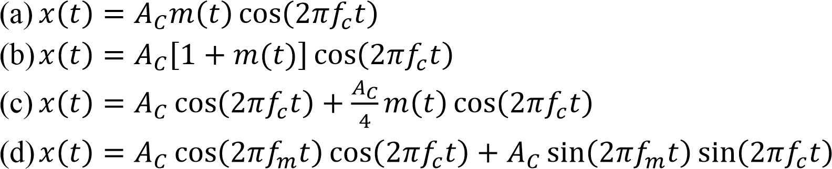

Soln. Given
Modulation signal (𝒕) = 𝟐 𝐜𝐨𝐬(𝟐𝝅𝒇_{𝒎}𝒕)
Carrier signal 𝒙(𝒕) = 𝑨_{𝑪} 𝐜𝐨𝐬(𝟐𝝅𝒇_{𝒄})𝒕
Since AM is DSB – FC (DSB full carrier)
Standard Expression is given by
𝒆(𝒕) = 𝑬_{𝑪}[𝟏 + 𝒎(𝒕)] 𝐜𝐨𝐬 𝝎_{𝒄}𝒕
Or (𝒕) = 𝑬_{𝑪}[𝟏 + 𝝁 𝐜𝐨𝐬 𝝎_{𝒎}𝒕] 𝐜𝐨𝐬 𝝎_{𝒄}𝒕 − − − − − (𝟏)
Option (b) is (𝒕) = 𝑨_{𝑪}[𝟏 + 𝟐 𝐜𝐨𝐬(𝟐𝝅𝒇_{𝒎}𝒕)] 𝐜𝐨𝐬 𝟐𝝅𝒇_{𝒄}𝒕
Comparing this expression with the standard one given equation (I)
We get µ = 2 i.e. conventional AM with over modulation
Option (c)
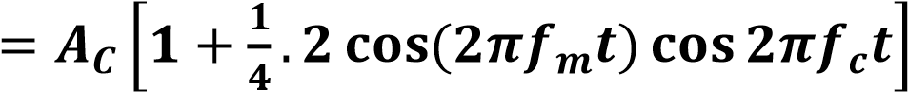
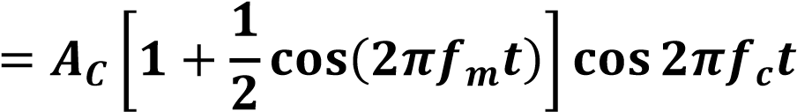
Here 𝝁 = ^{𝟏}⁄_{𝟐}

So, this represents conventional AM without over modulation.
Option (d) is non standard expression
So, correct option is option (c)

- For a message signal (𝑡) = cos(2𝜋𝑓_{𝑐}𝑡) and carrier of frequency𝑓_{𝑐}. Which of the following represents a single side-band (SSB) signal?
  - cos(2𝜋𝑓_{𝑚}𝑡) cos(2𝜋𝑓_{𝑐}𝑡)
  - cos(2𝜋𝑓_{𝑐}𝑡)
  - cos[2𝜋(𝑓_{𝑐} + 𝑓_{𝑚})𝑡]
  - [1 + cos(2𝜋𝑓_{𝑚}𝑡)]. cos(2𝜋𝑓_{𝑐}𝑡)

Soln. Option (a) in the problem represents AM signal DSB-SC. If will have both side bands
option (b) represents only the carrier frequency
Option (c), 𝐜𝐨[𝟐𝝅(𝒇_{𝒄} + 𝒇_{𝒎})𝒕] represents upper side band (SSB-SC). It represent SSB signal
Option (d) represents the conventional AM signal
Ans. Option (c)

- A DSB-SC signal is generated using the carrier cos(𝜔_{𝐶}𝑡 + 𝜃) and modulating signal x(t). The envelop of the DSB-SC signal is
  - 𝑥(𝑡) (c)Only positive portion of x(t)
  - |𝑥(𝑡)| (d)𝑥(𝑡) cos 𝜃

Soln. Given
Carrier (𝒕) = 𝐜𝐨𝐬(𝝎_{𝒄}𝒕 + 𝜽)

Modulating signal (𝒕) = 𝒙(𝒕)
DSB SC modulated signal is given by (𝒕).𝒎(𝒕) = 𝒔(𝒕)
= 𝒙(𝒕) 𝐜𝐨𝐬(𝝎_{𝒄}𝒕 + 𝜽)
= 𝒙(𝒕){𝐜𝐨𝐬 𝜽 . 𝐜𝐨𝐬 𝝎_{𝒄}𝒕 − 𝐬𝐢𝐧 𝜽 𝐬𝐢𝐧 𝝎_{𝒄}𝒕}
= 𝒙(𝒕) 𝐜𝐨𝐬 𝜽 . 𝐜𝐨𝐬 𝝎_{𝒄}𝒕 − 𝒙(𝒕).𝐬𝐢𝐧 𝜽 𝐬𝐢𝐧 𝝎_{𝒄}𝒕

Envelope of (𝒕) = √[𝒙(𝒕) 𝐜𝐨𝐬 𝜽]^{𝟐} + [𝒙(𝒕) 𝐬𝐢𝐧 𝜽]^{𝟐}
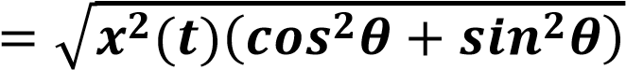
= 𝒙(𝒕)
Option (b) |(𝒕)|

9. A 1 MHz sinusoidal carrier is amplitude modulated by a symmetrical square wave of period 100 µsec. Which of the following frequencies will not be present in the modulated signal?
- 990 kHz (c)1020 kHz
- 1010 kHz (d)1030 kHz

Soln. Frequency of carrier signal is 𝟏𝑴𝑯𝒛 = 𝟏𝟎𝟎𝟎 𝑲𝑯𝒛
Modulation signal is square wave of period 100 µS.
Frequency 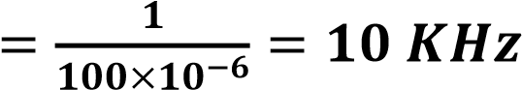
Since modulation signal is symmetrical square wave it will contain only odd harmonics i.e. 10 KHz, 30 KHz, 50 KHz -----etc.
Thus the modulated signal has
𝒇_{𝒄} ± 𝒇_{𝒎} = (𝟏𝟎𝟎𝟎 ± 𝟏𝟎𝑲𝑯𝒛) = 𝟏𝟎𝟏𝟎𝑲𝑯𝒛 & 𝟗𝟗𝟎 𝑲𝑯𝒛
𝒇_{𝒄} ± 𝟑𝒇_{𝒎} = (𝟏𝟎𝟎𝟎 ± 𝟑𝟎𝑲𝑯𝒛) = 𝟏𝟎𝟑𝟎𝑲𝑯𝒛 & 𝟗𝟕𝟎 𝑲𝑯𝒛

So, 1020 KHz will not be present in modulated signal
Option (c)

- A message signal given by 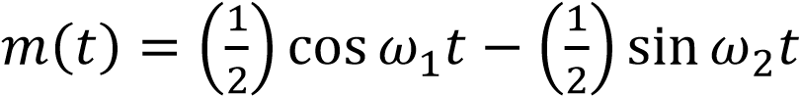 is amplitude modulated with a carrier of frequency ω_{c} to generate
(𝑡) = [1 + 𝑚(𝑡)] cos 𝜔_{𝑐} 𝑡
What is the power efficiency achieved by this modulation scheme?
    - 8.33% (c)20%
    - 11.11% (d)25%

Soln. Given
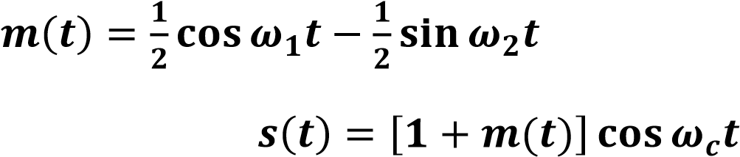
Note that the modulation frequency are 𝝎_{𝟏}𝒂𝒏𝒅 𝝎_{𝟐} i.e. multitone modulation
Net modulation index is
𝝁
=
√
𝝁
𝟏
𝟐
+
𝝁
𝟐
𝟐
+
−
−
𝝁
𝒏
𝟐
Here, 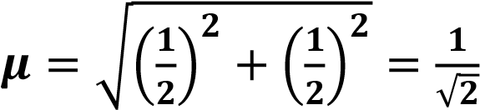
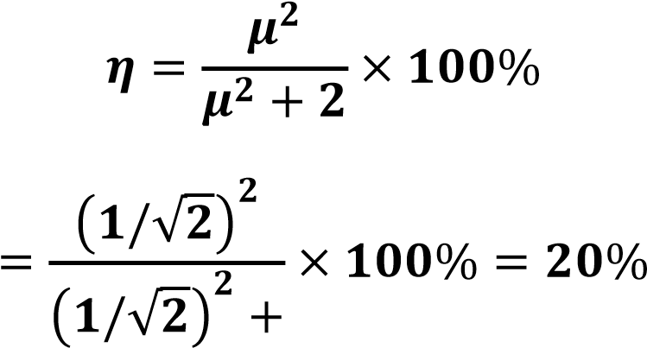
Option (c)

- A 4 GHz carrier is DSB-SC modulated by a low-pass message signal with maximum frequency of 2 MHz. The resultant signal is to be ideally sampled.
The minimum frequency of the sampling impulse train should be
    - 4 MHz (c)8 GHz
    - 8 MHz (d)8.004 GHz

Soln. Given
𝒇_{𝒄} = 𝟒 𝑮𝑯𝒛 = 𝟒𝟎𝟎𝟎 𝑴𝑯𝒛
𝒇_{𝒎} = 𝟐 𝑴𝑯𝒛 (𝒍𝒐𝒘 𝒑𝒂𝒔𝒔 𝒎𝒆𝒔𝒔𝒂𝒈𝒆 𝒔𝒊𝒈𝒏𝒂𝒍)
Such a signal is amplitude modulated (DSB-SC) i.e. two side bands
(𝒇_{𝒄} + 𝒇_{𝒎})&(𝒇_{𝒄} − 𝒇_{𝒎})
i.e. 4002 & 3998 or 4 MHz = BW so, min. sampling frequency should be (Nyquist Rate) option (b) 𝒇_{𝒔(𝒎𝒊𝒏)} = 𝟐 × 𝟒 = 𝟖 𝑴𝑯𝒛

- Consider the amplitude modulated (AM) signal𝐴_{𝐶} cos 𝜔_{𝑐}𝑡 +
2 cos 𝜔_{𝑚} 𝑡 cos 𝜔_{𝑐}𝑡. For demodulating the signal using envelope detector, the minimum value of A_{C} should be
    - 2 (c)0.5
    - 1 (d)0

Soln. Modulated signal is given as
𝝋_{𝑨𝑴}(𝒕) = 𝑨_{𝒄} 𝐜𝐨𝐬 𝝎_{𝒄}𝒕 + 𝟐 𝐜𝐨𝐬 𝛚_{𝐦}𝐭. 𝐜𝐨𝐬 𝝎_{𝒄}𝒕
𝝋_{𝑨𝑴}(𝒕) = [𝑨_{𝒄} + 𝟐 𝐜𝐨𝐬 𝝎_{𝒄}𝒕] 𝐜𝐨𝐬 𝝎_{𝒎}𝒕
Note that for envelope detection the modulation should not go beyond full modulation i.e. 𝝁 = 𝟏, so amplitude of baseband signal has to be less than the carrier amplitude (A_{c})

|𝒇(𝒕)|_{𝒎𝒂𝒙} ≤ 𝑨_{𝒄}
i.e. |𝟐 𝐜𝐨𝐬 𝝎_{𝒎}𝒕|_{𝒎𝒂𝒙} = 𝟐 ≤ 𝑨_{𝒄}
or𝑨_{𝒄} ≥ 𝟐 option (a)

- Which of the following demodulator (s) can be used for demodulating the signal
(𝑡) = 5(1 + 2 cos 200 𝜋𝑡)𝑐𝑜𝑠20000𝜋𝑡
    - Envelope demodulator (c)Synchronous demodulator
    - Square-law demodulator (d)None of the above

Soln. The modulated signal given is (𝒕) = 𝟓(𝟏 + 𝟐 𝐜𝐨𝐬 𝟐𝟎𝟎𝝅𝒕). 𝐜𝐨𝐬 𝟐𝟎𝟎𝟎𝝅𝒕
The standard equation for AM is
𝑿_{𝑨}(𝒕) = 𝑨_{𝒄}(𝟏 + 𝝁 𝐜𝐨𝐬 𝝎_{𝒎}𝒕) 𝐜𝐨𝐬 𝝎_{𝒄}𝒕 If we compare the two equation we find 𝝁 = 𝟐.
The modulation index is more than 1 here, so it is the case of over modulation.
When modulation index is more than 1 (over modulation) then detection is possible only with, Synchronous modulation, such signal can not be detected with envelope detector.
Option (c)

- The amplitude modulated wave form (𝑡) = 𝐴_{𝐶}[1 + 𝐾_{𝑎}𝑚(𝑡)] cos𝜔_{𝐶}𝑡 is fed to an ideal envelope detector. The maximum magnitude of 𝐾_{𝑎}(𝑡) is greater than 1. Which of the following could be the detector output ?
  - 𝐴_{𝑐}𝑚(𝑡) (c)|𝐴_{𝐶}[1 + 𝐾_{𝑎}𝑚(𝑡)]|
  - 𝐴²_{𝑐}[1 + 𝐾_{𝑎}𝑚(𝑡)]² (d)𝐴_{𝐶}|1 + 𝐾_{𝑎}𝑚(𝑡)|²

Soln. Given
|𝑲_{𝒂}𝒎(𝒕)|>|
For the above condition the AM signal is over modulated. Envelope detector will not be able to detect over modulated signal correctly.
Non of the above options

- The diagonal clipping in Amplitude Demodulation (using envelope detector) can be avoided if RC time-constant of the envelope detector satisfies the following condition, (here W is message bandwidth and ω is carrier frequency both in rad/sec)
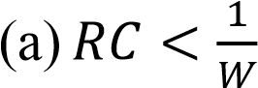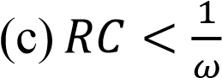
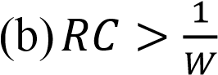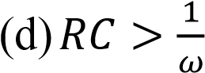

Soln. It is seen that to avoid negative peak clipping also said diagonal clipping the RC time constant of detector should be
Or 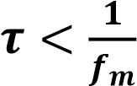
Note f_{m} is maximum modulating frequency i.e. the bandwidth w
So, 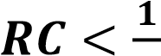
𝒘
Option c
- An AM signal is detected using an envelope detector. The carrier frequency and modulation signal frequency are 1 MHz and 2 KHz respectively. An
appropriate value for the time constant of the envelope detector is
  - 500 µsec (c)0.2 µsec
  - 20 µsec (d)1 µsec

Soln. Note that the time constant RC should satisfy the following condition
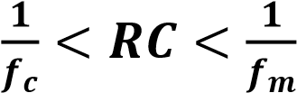
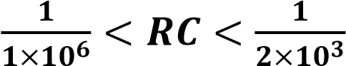
Or 𝟏 𝝁𝒔 < 𝑹𝑪 < 𝟎. 𝟓𝒎𝒔
Option (b)

- A DSB-SC signal is to be generated with a carrier frequency 𝑓_{𝑐} = 1𝑀𝐻𝑧 using a non-linear device with the input-output characteristic
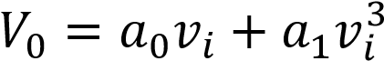
Where a₀ and a₁ are constants. The output of the non-linear device can be filtered by an appropriate band-pass filter.
Let 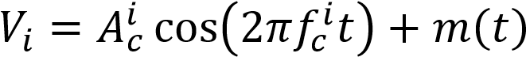 where m(t) is the message signal. Then the value of 𝑓_{𝑐}^{𝑖} (in MHz) is
  - 1.0 (c)0.5
  - 0.333 (d)3.0

Soln.
+𝝋_{𝟏}[𝑨^{𝒊}_{𝒄}𝝋_{𝑨𝑴}(𝒕) = 𝑨_{𝒄} 𝐜𝐨𝐬 𝝎_{𝒄}𝒕 𝟐 𝐜𝐨𝐬 𝝎_{𝒄}𝒕]
= 𝝋_{𝟎}[𝑨^{𝒊}_{𝒄} 𝐜𝐨𝐬(𝟐𝝅𝒇^{𝒊}_{𝒄}𝒕) + 𝒎(𝒕)]
+𝝋_{𝟏} [(𝑨^{𝒊}_{𝒄})^{𝟑}𝒄𝒐𝒔^{𝟑}(𝟐𝝅𝒇^{𝒊}_{𝒄}𝒕) + 𝒎^{𝟑}(𝒕)]
+𝟑. 𝑨^{𝒊}_{𝒄} 𝐜𝐨𝐬(𝟐𝝅𝒇^{𝒊}_{𝒄}𝒕).𝒎^{𝟐}(𝒕) + 𝟑. (𝑨^{𝒊}_{𝒄})^{𝟐}𝒄𝒐𝒔^{𝟐}(𝟐𝝅𝒇^{𝒊}_{𝒄}𝒕).𝒎(𝒕)
AM – DSB – SC signal lies is
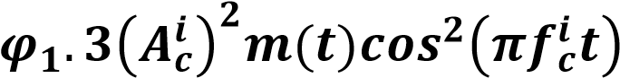
For DSB – SC the last term is important

𝟑𝝋_{𝟏}(𝑨^{𝒊}_{𝒄})^{𝟐}𝒄𝒐𝒔^{𝟐}𝟐𝝅𝒇^{𝒊}_{𝒄}𝒕.𝒎(𝒕)
𝟑 𝝋_{𝟏}(𝑨^{𝒊}_{𝒄})^{𝟐}. 𝒎(𝒕). [𝟏 + 𝐜𝐨𝐬 𝟐𝝅(𝟐𝒇^{𝒊}_{𝒄})𝒕] Note (𝒕) 𝐜𝐨𝐬 𝝎_{𝒄}𝒕 → 𝒇_{𝒄} (𝒄𝒂𝒓𝒓𝒊𝒆𝒓) = 𝟏𝑴𝑯𝒛
For 𝒄𝒐𝒔^{𝟐} term as expended the term is having 𝟐𝒇^{𝒊}_{𝒄}
Option (c)
18.A message signal 𝑚(𝑡) = cos 2000 𝜋𝑡 + 4 cos 4000 𝜋𝑡 modulates the carriers 𝑐(𝑡) = cos 2𝜋𝑓_{𝑐}𝑡 where 𝑓_{𝑐} = 1𝑀𝐻𝑧 to produce an AM signal. For demodulating the generated AM signal using an envelope detector, the time constant RC of the detector circuit should satisfy
- 0.5 ms< RC < 1 ms (c)RC<< 1 µs
- 1 µs << RC < 0.5 ms (d)RC >> 0.5 ms

Soln. Message signal is
𝒎(𝒕) = 𝐜𝐨𝐬 𝟐𝟎𝟎𝟎𝝅𝒕 + 𝟒 𝐜𝐨𝐬 𝟒𝟎𝟎𝟎𝝅𝒕
It consist of two frequencies 𝝎_{𝟏} = 𝟐𝟎𝟎𝟎𝝅
Or 𝟐𝝅𝒇_{𝟏} = 𝟐𝟎𝟎𝟎𝝅
Or 𝒇_{𝟏} = 𝟏𝑲𝑯𝒛
𝒇_{𝟐} = 𝟐 𝑲𝑯𝒛
So, Max frequency is 2 KHz
So, 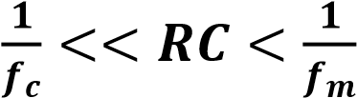

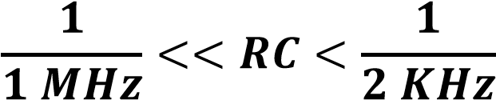
Or, 𝟏𝝁𝒔 << 𝑹𝑺 < 𝟎. 𝟓𝒎𝒔
Option (b)

- A super heterodyne radio receiver with an intermediate frequency of 455 KHz is tuned to a station operating at 1200 KHz. The associated image frequency is ₋₋₋₋₋₋₋₋₋₋₋KHz
Soln. In most receivers the local oscillator frequency is higher than incoming signal i.e.
𝒇_{𝟎}(𝒇𝒓𝒆𝒒𝒖𝒆𝒏𝒄𝒚 𝒐𝒇 𝒍𝒐𝒄𝒂𝒍 𝒐𝒔𝒄𝒊𝒍𝒍𝒂𝒕𝒐𝒓) = 𝒇_{𝒔} + 𝒇_{𝒊}
Where 𝒇_{𝒔}------- signal frequency
𝒇_{𝒊}𝒐𝒓 𝒇_{𝒔𝒊} -------- Image frequency

𝒇_{𝒔𝒊} = 𝒇_{𝒔} + 𝟐𝑰𝑭 = 𝒇_{𝒔} + 𝟐𝒇_{𝒊}
𝒇_{𝒔𝒊} = 𝟏𝟐𝟎𝟎 + 𝟐(𝟒𝟓𝟓)
𝒇_{𝒔𝒊} = 𝟐𝟏𝟏𝟎 𝑲𝑯𝒛 so, answer is 2110 KHz

- The image channel selectivity of superheterodyne receiver depends upon
  - IF amplifiers only
  - RF and IF amplifiers only
  - Pre selector, RF and IF amplifiers
  - Pre selector and RF amplifiers

Soln. Image rejection depends on front end selectivity of receiver and must be achieved before If stage. So image channel selectivity depends upon pre selector & RF amplifier. If it enters IF stage it becomes impossible to remove it from wanted signal.
Option (d)
21. Which of the following schemes suffer from the threshold effect?
- AM detection using envelope detectors
- AM detection using synchronous detection
- FM detection using a discriminator
- SSB detection with synchronous detection
Option (c)
22. In a super heterodyne AM receiver the image channel selectivity is determined by
- The pre selector and RF stages
- The pre selector , RF and IF stages
- The IF stage
- All of above
Option (a)
23. The input to a coherent detector is DSB SC signal plus noise. The noise at the detector output is
- In phase component
- Quadrature component
- Zero
- Envelope

Option (a)

24. Which of the following schemes requires minimum transmitted power and maximum channel bandwidth
- VSB
- DSB SC
- SSB
- AM
Option (a)
25. The noise at the input to an ideal frequency detector is white. The detector is operating is operating above threshold. The power spectral density of the noise at the output is
- Raised cosine
- Flat
- Parabolic
- Gaussian

Option (c)
26. A zero mean white Gaussian noise is passed through an ideal LPF of bandwidth 10 kHz. The output is then uniformly sampled with sampling period ts= 0.03 ms. The samples so obtained would be
- Correlated
- Statiscally independent
- Uncorrelated
- Orthogonal

Option (b)
27. If E denotes the expectation, the variance of a random variable X is given by
- E[X^2] – E^2[X]
- E[X^2] +E^2[X]
- E[X^2]

- E^2[X]

Option (a)
28. A message signal m(t) is band limited to wm. It is frequency translated by multiplying it by a signal Acos wct. What should be the value of wc if the bandwidth of the resultant signal is 0.5% of the carrier frequency.
- 100wm
- 400wm
- 200wm
- 300wm

Soln: Given 0.5 wm /100 = 2 wm
Hence wc =400 wm

Option ( b)
29. Percentage saving in power of 100% modulated SSB SC AM signal as compared to DSB signal is given by
- 100
- 66.67
- 150
- 83.33
Option ( b)
30. A balanced modulator is used for the generation of
- AM
- DSB SC
- SSC SC
- VSB
Option ( b)

