Fundamentals of Computing
Question Bank
Unit-1
Q.1 Define computer.
A.1 Computer is an electronic device which is capable of receiving information (data) in a particular form and of performing a sequence of operations in accordance with a predetermined but variable set of procedural instructions (program) to produce a result in the form of information or signals.

Q.2 Draw basic architecture of computer system.
A.2
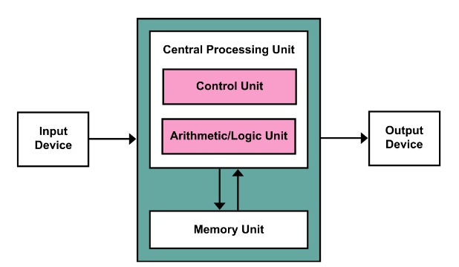

Q.3 What is input unit in computer?
A.3 In computing, an input device is (a piece of computer hardware equipment) used to provide data and control signals to an information processing system such as a computer or information appliance. Examples of input devices include keyboards, mouse, scanners, digital cameras and joysticks.

Q.4 What is output unit in computer?
A.4 An output device is any device used to send data from a computer to another device or user. Most computer data output that is meant for humans is in the form of audio or video. Thus, most output devices used by humans are in these categories. Examples include monitors, projectors, speakers, headphones and printers.

Q.5 What is central processing unit in computer?
A.5 A central processing unit (CPU) is the electronic circuitry within a computer that carries out the instructions of a computer program by performing the basic arithmetic, logical, control and input/output (I/O) operations specified by the instructions.

Q.6 What is central processing unit in computer?
A.6 An arithmetic logic unit (ALU) is a combinational digital electronic circuit that performs arithmetic and bitwise operations on integer binary numbers. The inputs to an ALU are the data to be operated on, called operands, and a code indicating the operation to be performed; the ALU's output is the result of the performed operation.

Q.7 What is control unit in computer?
A.7 The control unit (CU) is a component of a computer's central processing unit (CPU) that directs the operation of the processor. It tells the computer's memory, arithmetic/logic unit and input and output devices on how to respond to a program's instructions. It directs the operation of the other units by providing timing and control signals. Most computer resources are managed by the CU. It directs the flow of data between the CPU and the other devices.

Q.8 What is storage unit in computer?
A.8 Computer data storage, often called storage or memory, is a technology consisting of computer components and recording media that are used to retain digital data. It is a core function and fundamental component of computers.

