Subject: Engineering Mechanics
Semester: 2nd
Subject Code: ETME 110

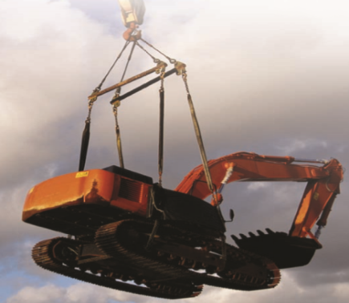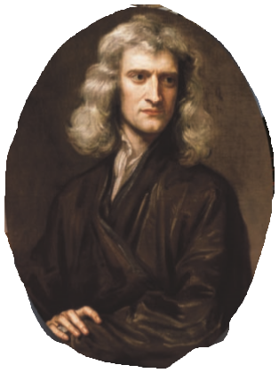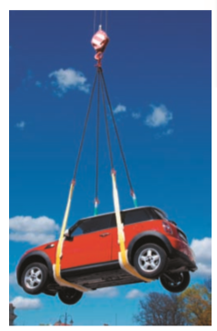

Unit : 1

FORCE SYSTEM

Q1. Resolve a force of 100 N in to two components of 200N each. Draw the sketch.

Q2. A car is pulled by means of two opens as shown in figure (1). The tension in rope AB is 2.4 KN and the angle ά = 25. If the resultant of two forces applied at A is directed along the axis of the car, find the tension in rope AC

and magnitude of the resultant.

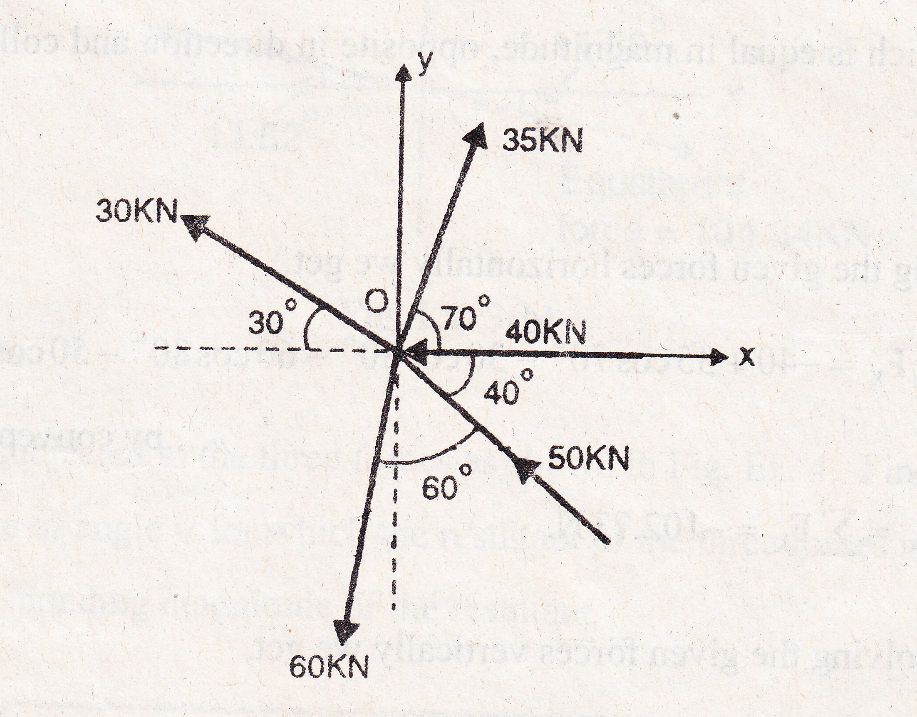
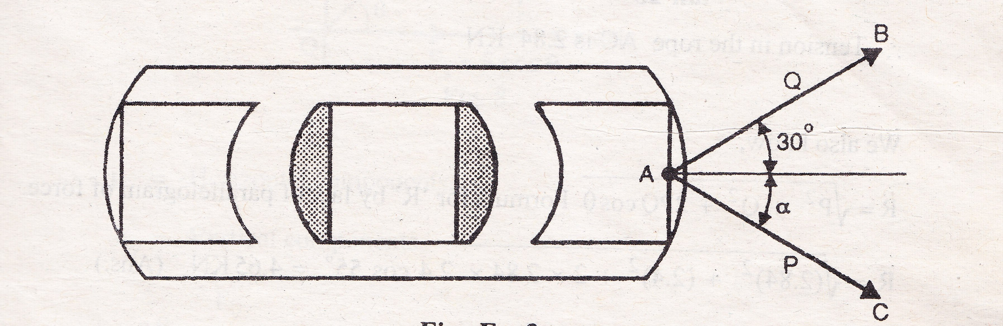

Fig.1 Fig.2

Q3. Find the equilibrant of the system of forces shown in figure (2).

Q4. A trolley is subjected to the three forces as shown in figure(3). Find the value of angle ά for which the resultant of the three forces is vertical. Also the corresponding magnitude of the resultant.

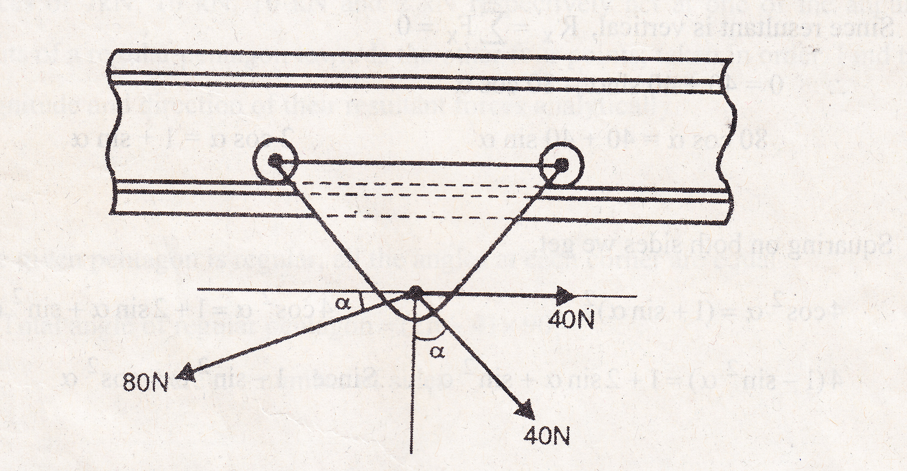

Fig.3

Q5. The angle between the two forces of magnitudes 20 KN and 15 KN is 60, the 20 KN force is horizontal .Determine the resultant in magnitude and direction, if (1) the forces are pull; (2) If the 15 KN is a push and 20 KN force is a pull.

Q6. A wheel has five equally spaced spokes, all in tension, as shown in fig (4). If the tensions of three consecutive spokes are 500 N, 700N, 600N respectively, find the tensions in other two spokes.
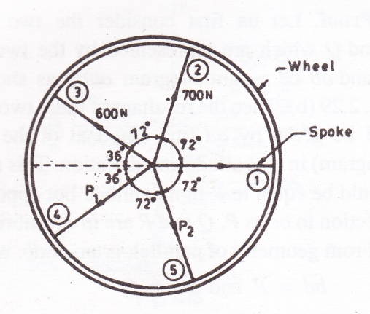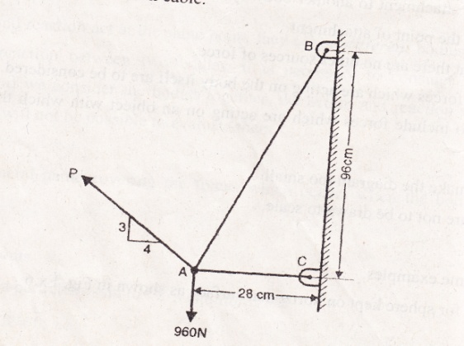
Fig.4 Fig.5

Q7. Two cables are tied together at A and laded as shown in fig (5). if P=640 N, Find the tension in each cable.

Q8. A 250 kg cylindrical roller, 2m in diameter, is just to be raised over 0.5 m obstruction. A cable is wrapped around the tank and pulley horizontally as shown fig (6). find the required tension in the cable and the reaction at A.

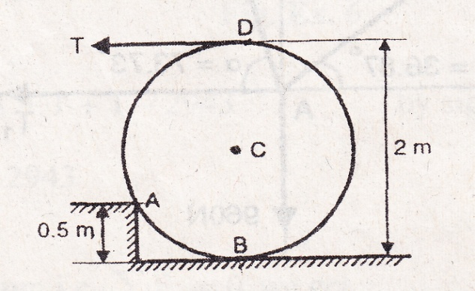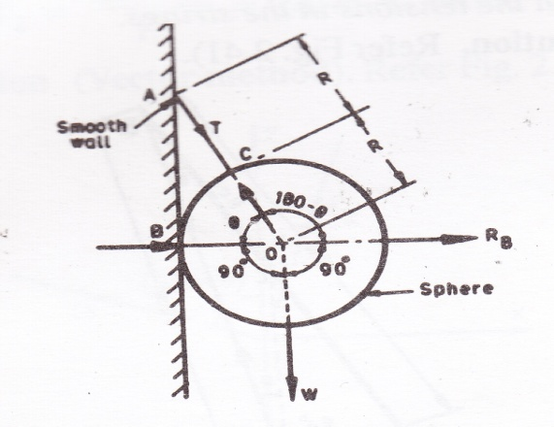
Fig.6 Fig.7

Q9.A smooth sphere of weight ‘W’ is supported in contact with a smooth vertical wall by a string fastened to a point on its surface, the end being attached to a point on the wall .if the length of the string is equal to the radius of sphere. Find tensions in the string and reaction on the wall. (As shown in fig.7).

Q10. One end of rod AB rests in the corner A and the other is attached to the cord BD.Refer figure (8). If the rod supports a 150 N load at its midpoint C, find the reaction at A and the tension is the cord.

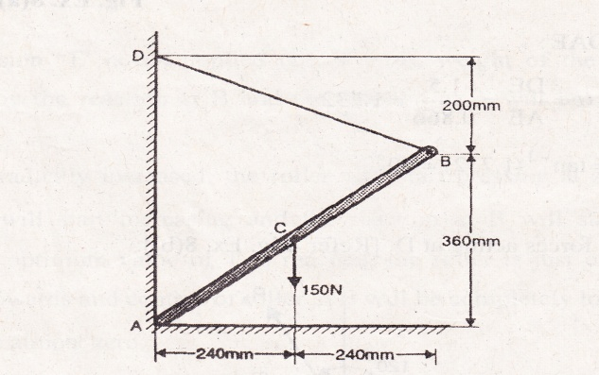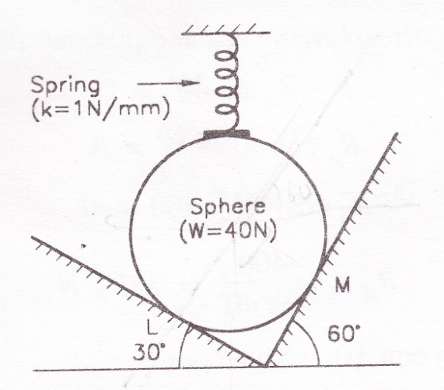

Fig.8 Fig.9
Q11.A sphere resting in a smooth V shaped groove and subjected to a spring force .the spring is compressed to a length of 100mm from its free length of 150mm .if the stiffness of spring k=2N/mm .Determine the contact reaction at the points L and M. (As shown in fig.9).

Q12.What axial forces do the vertical load W=800 N induce in the tie rod and the jib of the crane shown in fig.(10).

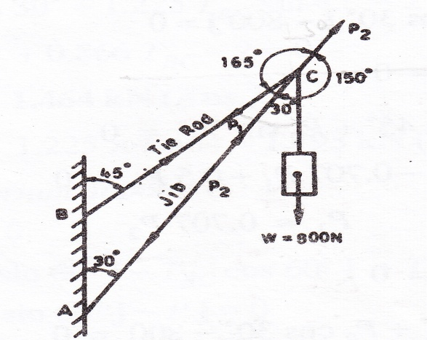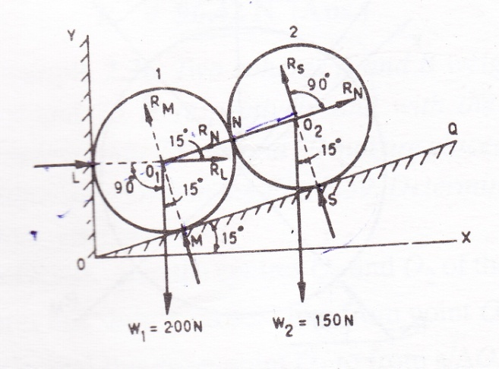

Fig.10 Fig.11

Q13.The cylinder shown in fig.(11) have same diameter but the cylinder 1 weighs 200N and cylinder 2 weighs 150 N .Find the reaction at the supports
.

Q14. Find the resultant of a parallel force system as shown in figure(12).

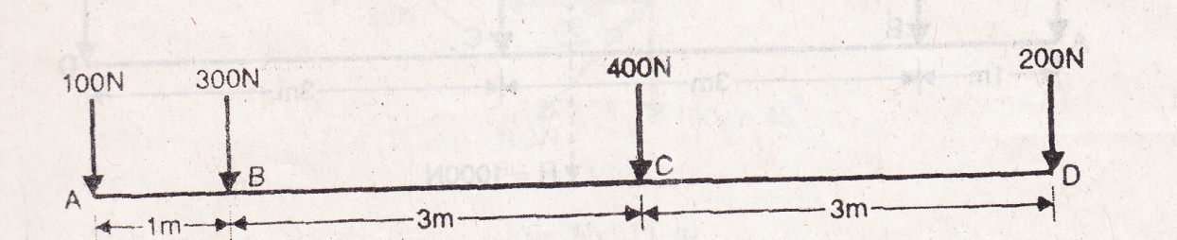

Fig.12

Q15.The spanner shown in fig.(13) is used to rotate a shaft. A pin fits in a hold at A. while a flat frictionless surface rests against the shaft at B.If a 300 N force P is exerted on the spanner at D, then find the reactions at A and B.
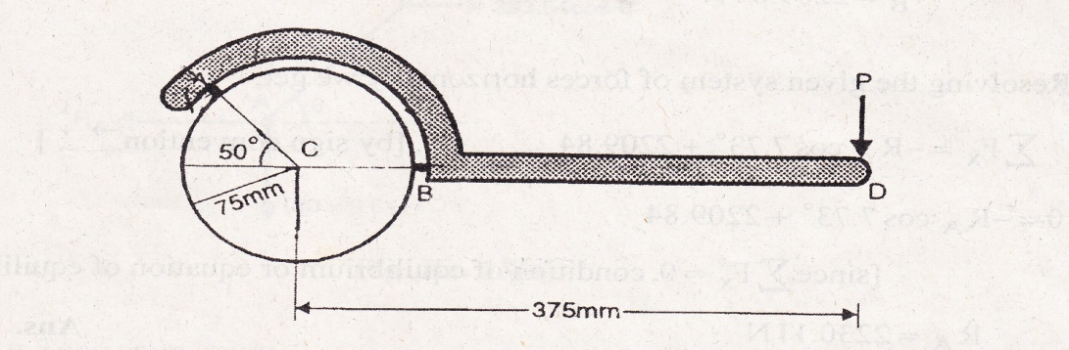
Fig.13
Q16. The 30 kg collar may slide on a frictionless vertical rod and is connected to a 34 kg counter weight. Find the value of h for which the system is in equilibrium. Refer fig.14
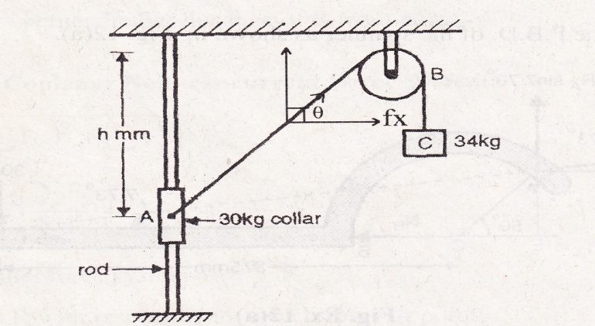
Fig.14

Q17.Forces 1P, 3P,-4P act in order round the sides of an equilateral triangle of side 20 mm drawn on a rigid lamina. Find the magnitude, direction and position of their resultant.(fig.15)

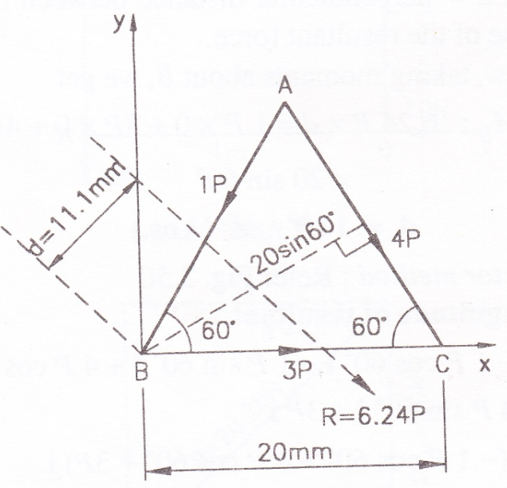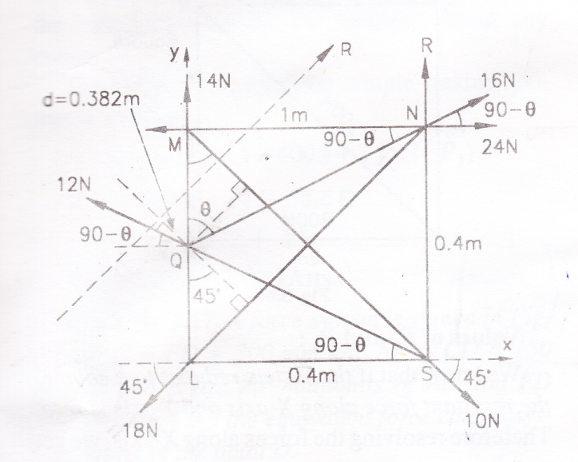
Fig.15 Fig.16
Q18. LMNS is a square, each side being .4m, and Q is the middle point of LM.forces of 14, 16,24,10,18 and 12 N acts in the line of directions LM, QN, MN, MS, NL and SQ respectively. Find the magnitude, direction and resultant of force. (fig.16)

Q19.Find the magnitude, direction and position of the resultant of the system of the forces from point A.(fig.17)

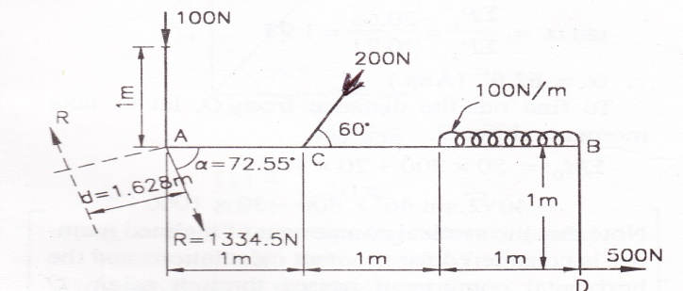
Fig.17
Q20.A beam simply supported at both the ends carries load system (as shown in fig.18). Find the reaction at the two ends.

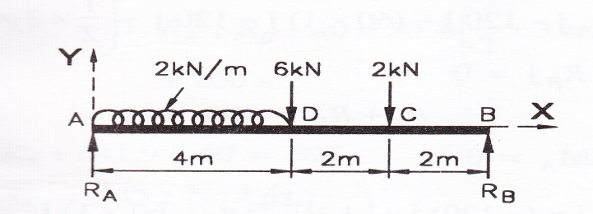
Fig.18

Unit : 1

CENTRE OF GRAVITY

Q1.Find out the c.g. of following using method of integration.
(a). Right circular cone
(b). Solid hemisphere
( c). Triangular lamina
(d). Semicircular lamina
(e). Semicircular arc

Q2.Find out the c.g. of the area of a sector of angle α of a circle of radius r as shown in fig. using method of integration.

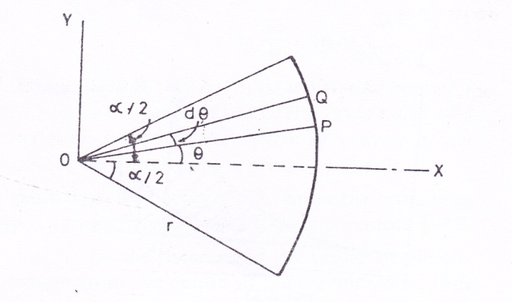
Fig.1

Q3.Find out the centroid of shaded area under the curve using direct integration method. (fig2)
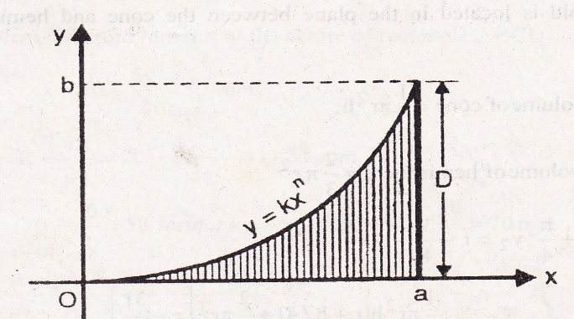
Fig.2

Q4.Find out position of the centroid of L section (as shown in the figure.3).

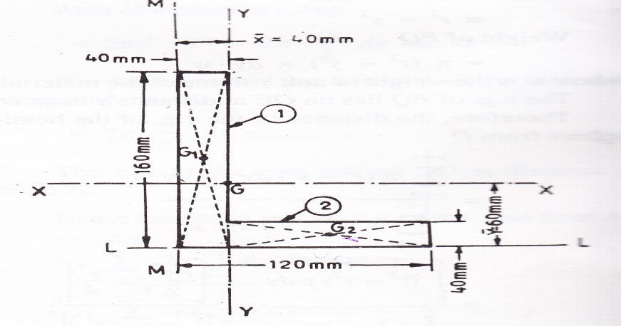
Fig.3

Q5.Determine the position of the centroid of I section (as shown in the fig4).
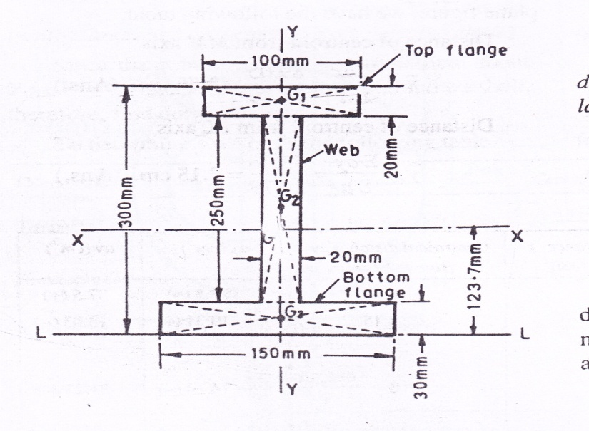
Fig.4

Q6. Determine the centroid of the lamina (shown in fig.5).

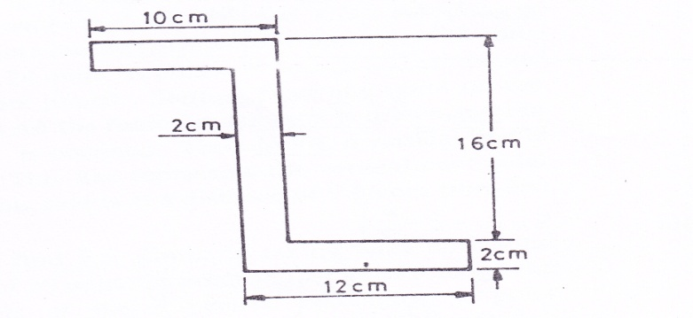
Fig5

Q7.From a uniform circular disc of radius ‘a’ is cut off a circular position of a radius a/2. Find the distance between the centers of the disc and hole if the centre of the mass of the remainder is on the circumference of the hole.(fig.6)
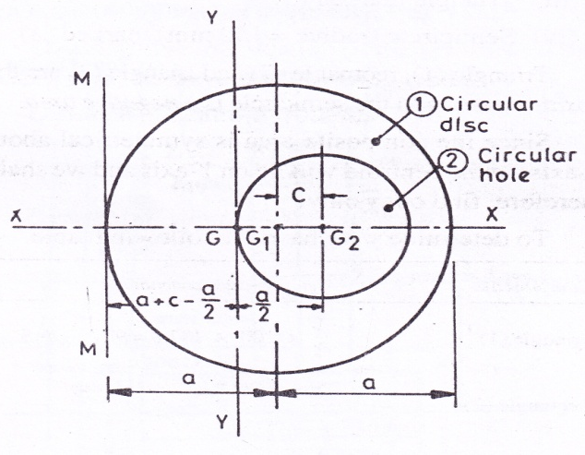
Fig.6

Q8.Using the analytical method. Determine the centre of gravity of the plane uniform lamina as shown in the fig(7).
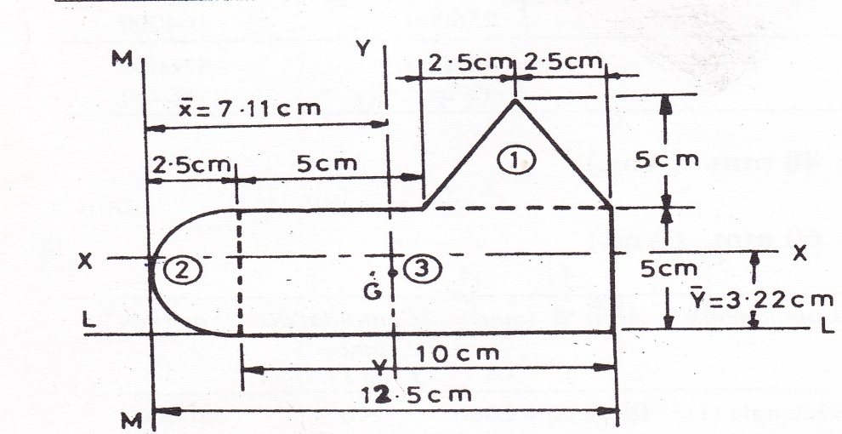

Fig.7

Q9.A square hole is punched out of a circular lamina, a diagonal of such a square being along any radius of the circle with one vertex at the centre of the circular lamina. It is said that the length of the said diagonal is equal to the radius of circular lamina. Find the centre of gravity of the remainder, if r be the radius of the circle. (fig8)

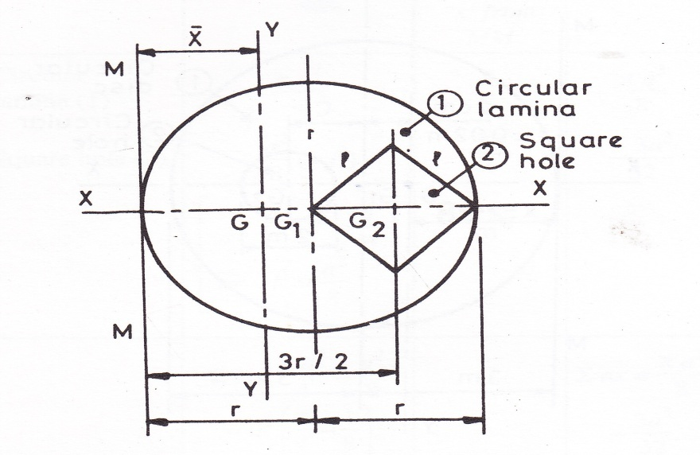

Fig.8

Q10.Determine the c.g. of the lamina shown in the figure. (9)

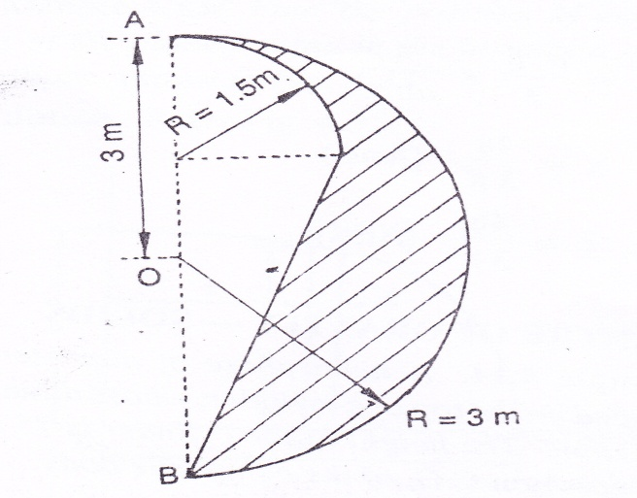

Fig.9

Q11.A thin rod is bent in to a shape as shown in fig.10. Determine the centroid of the bent rod.
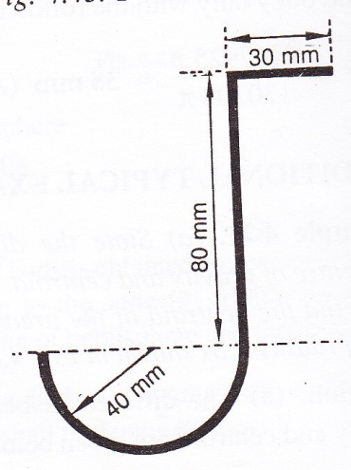
Fig.10

Q12..A right circular cone of base “r” is attached to a hemisphere of radius “r” .Determine the height “h” of the cone so that the centroid is located in the plane between the cone and hemisphere.(fig.11)

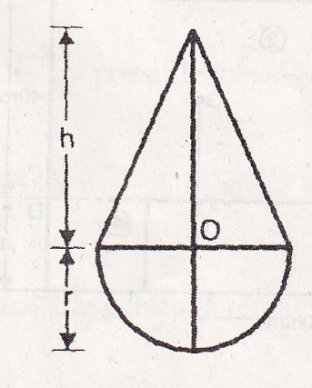

Fig.11

Unit : 1

MOMENT OF INERTIA

- Find the moment of inertia about the centroidal axis XX and YY of the section as shown in figure.

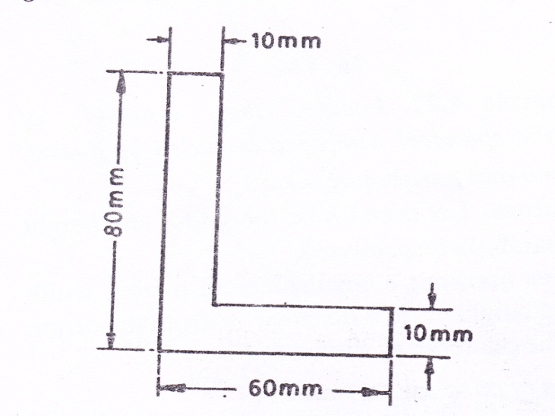

- Calculate the moment of inertia about horizontal and vertical gravity axes(Ixx and Iyy) of the section shown in figure.
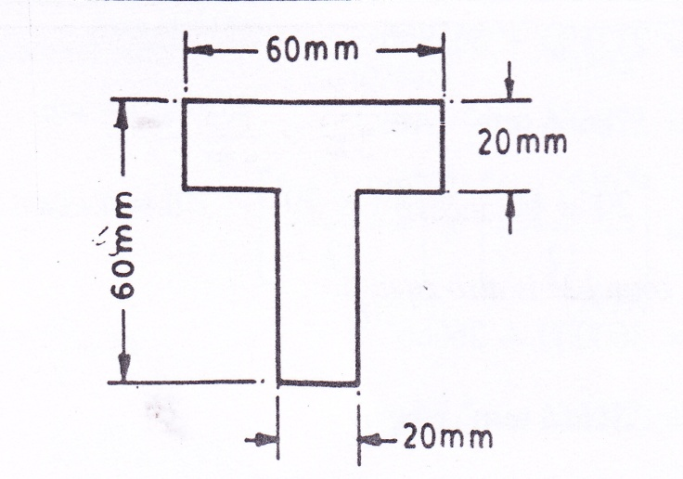

- A T-beam is made up of two plates and two angles as shown in figure. Determine the moment of inertia of T- section about an axis passing through the centroid of the section and parallel to the top plate.
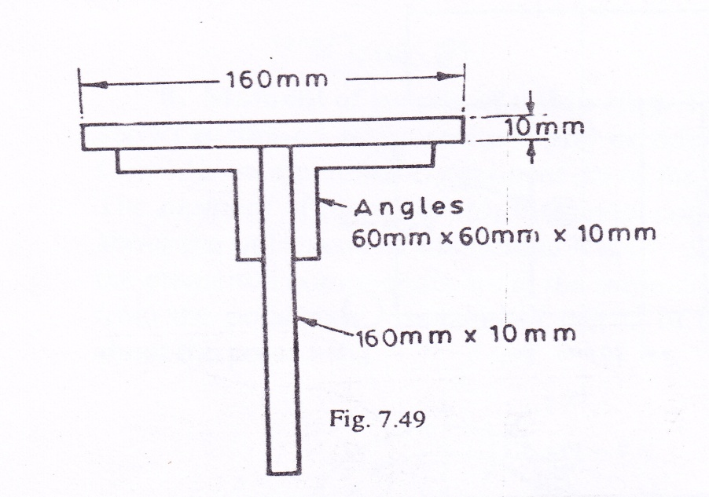

- Find the moment of inertia and radius of gyration of the area shown in figure about the axis AB.

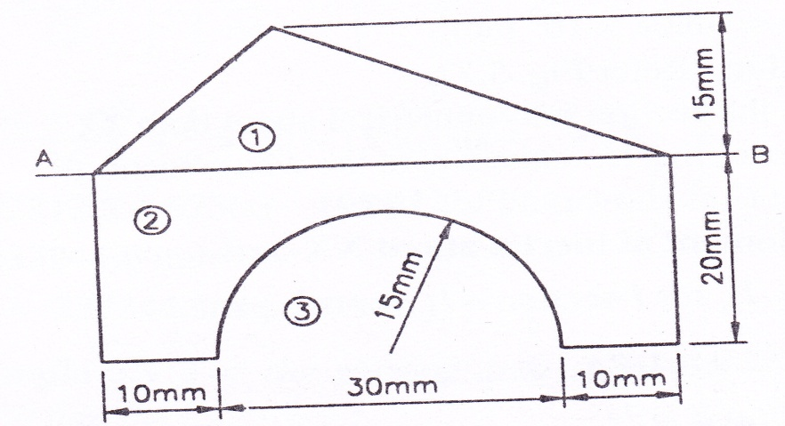

- A compound section is formed by riveting 200 m x100m flat plates, one on each flange of(OSL 300) 300 mm x 150 mm I-section girder. Find for the compound section:
(i) I_{xx} (ii) I_{yy} and
(iii) The least radius of the gyration.
The properties of I-section are as follows:
I_{xx} = 7322.9 x 10⁴ mm⁴
I_{yy} = 376.2 x 10⁴ mm⁴, and
Area = 48.08 x 10² mm²
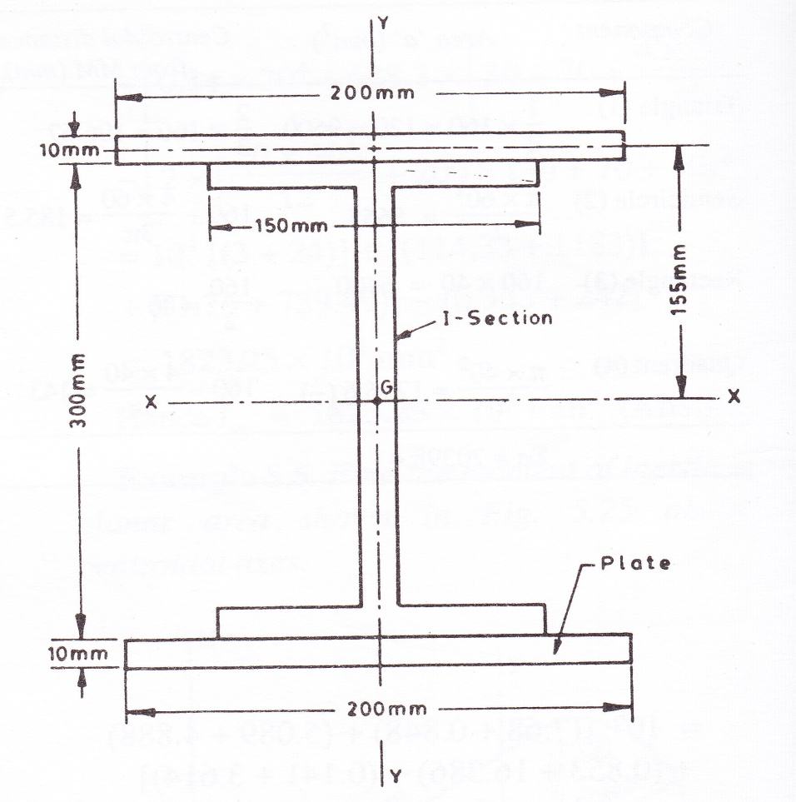

- Find the centroidal moment of the shaded area shown in the figure.

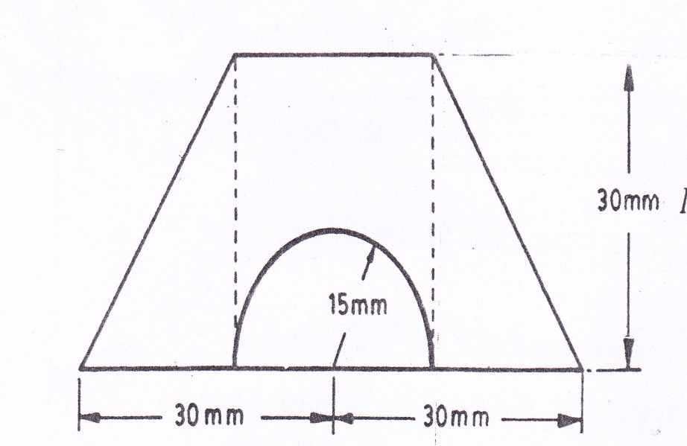

- For the shaded area shown in the figure,find the following:
- The position of the centroid
- The second moment of area about the base
- The radius of gyration about the base.

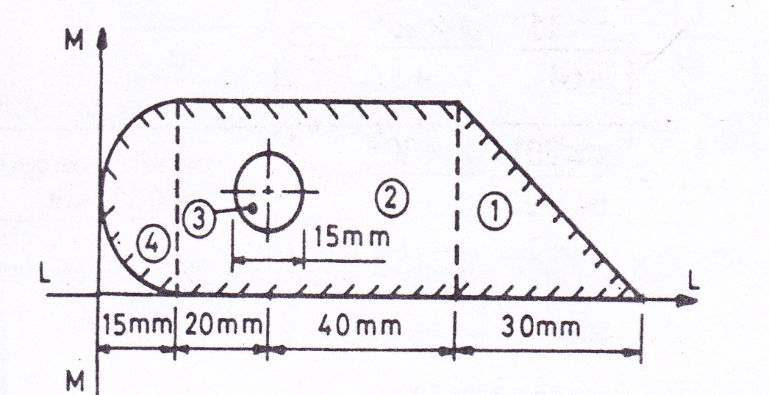

- Determine the moment of inertia of the shaded area about the edge LM as shown in fgure.
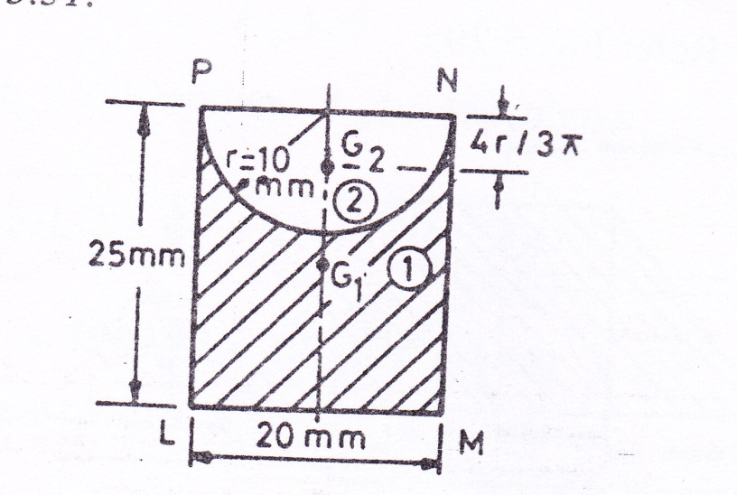

- Find the second moment of area about the indicated X and Y axes for the lamina shown in figure

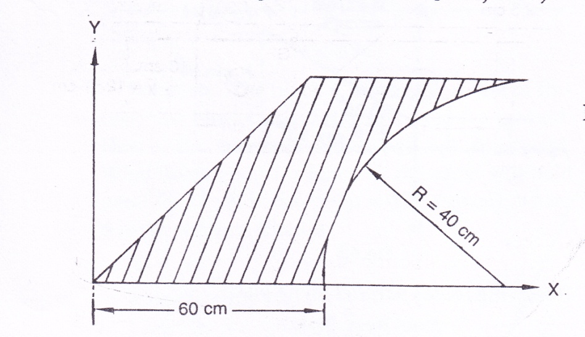

Unit: 2

STRUCTURE-TRUSS

Q1. A truss as shown in fig 1 with a span of 5 m and carrying a load of 5kN at its apex. Find the forces in all the members of the truss. (Method of joint)
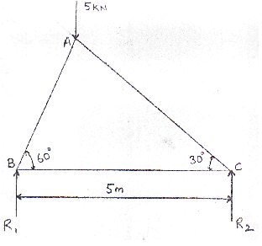
Fig. 1
Q2.A truss of 12 m span is loaded as shown in fig.2. Find the forces in the members of the truss by method of joint.
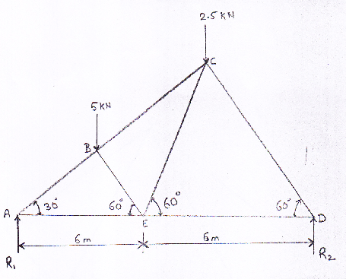
Fig 2

Q3.A warren girder consisting of seven members each of 4 m length freely supported at its end and loaded as shown in fig 3. Determine the stresses in the members by method of joints.
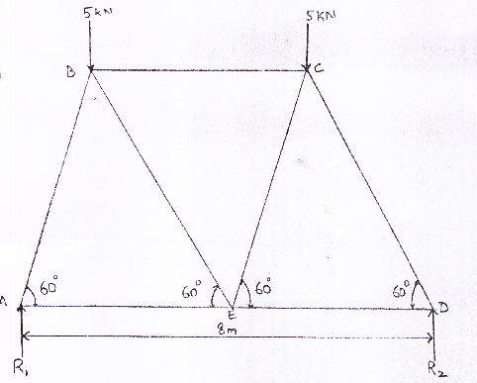
Fig 3

Q4. An inclined truss loaded as shown in fig 4. Determine the forces in the members of the truss by the method of joint.

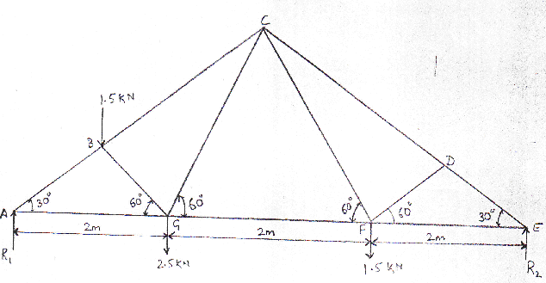
Fig.4

Q5. A roof truss in fig.6 is supported and loaded as shown. Find the forces in the members CE and FG by the method of sections.
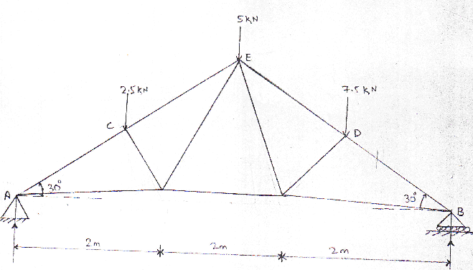

Fig.5

Q6. Determine the forces in the member BC, HC and HG by method of sections only. as shown in fig.

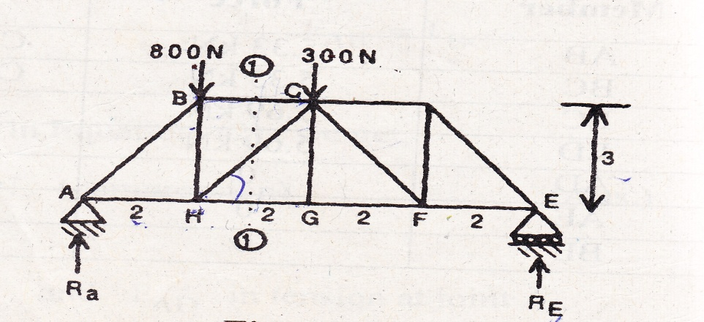

Fig6

Q7. A simple supported truss is loaded as shown in fig. Determine,(1) Reaction at the supports. (2) Forces in the members DE, DG and GH by method of section.

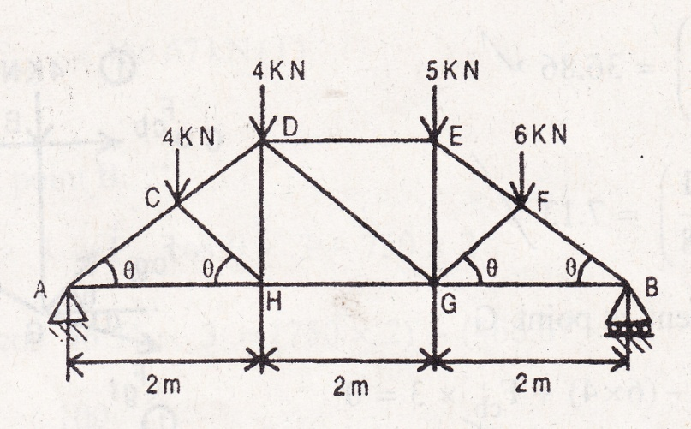

Fig.7

Q8. Determine the forces in the members BC, CG, CD and FE of a truss shown in fig below by method of section.

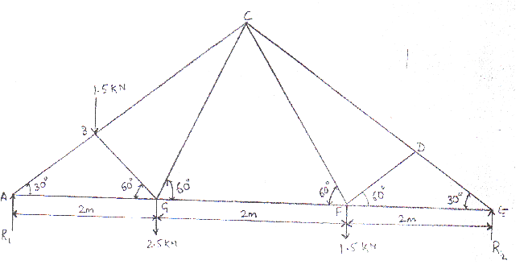

Fig.8

Q9.A cantilever truss is loaded as shown in fig. Find the forces in all the members of the truss by method of section.

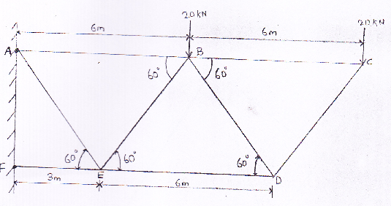
Fig.9

Q10. Find the forces induced in the member BC, CG and GF by method of section only for a cantilevers truss as shown in fig.

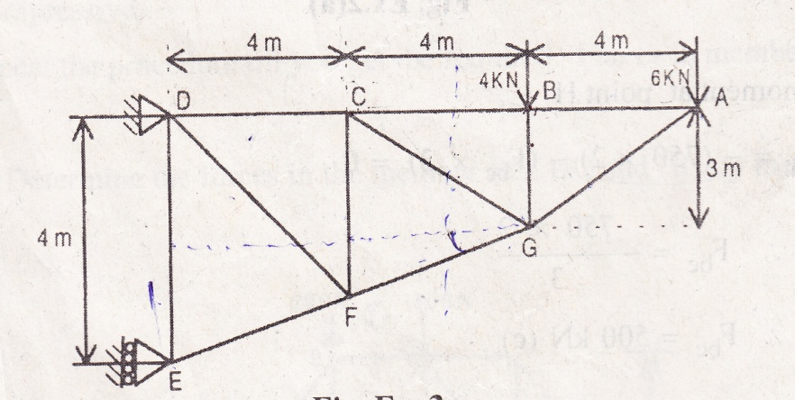

Fig.10

Q11.Find the forces induced in members due to a load of 2 KN at joint C, in truss shown in fig.

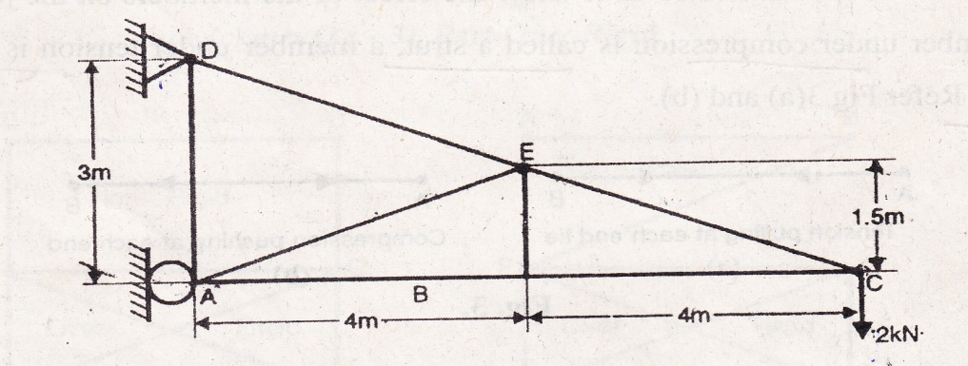

Fig.11

Q12. Determine the forces in all the members of the truss shown in fig.13. below.

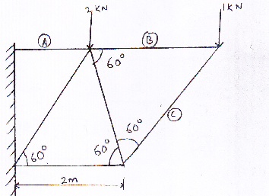

Fig.12

Unit: 2

FRICTION

Q1: A body resting on a rough Horizontal plane required a pull of 18 N inclined at 30° to the plane just to move it. It was found that a push of 22 N inclined at 30° to the plane just move the body. Determine the weight of the body and co-efficient of friction.

Q2: A body of weight 100 N rest on a rough plane inclined 30 ° with the horizontal. A force P acts on the body through its center of gravity and parallel to the plane. Find the range of force P for the body to remain in equilibrium. Take the co-efficient of friction between the body and the plane as 0.3.

Q3: A block of Weight 120 N is placed on an inclined plane which makes an angle of 40° with reference to the horizontal as shown in fig. Find if the block is in equilibrium. If not determine the magnitude of minimum force which is parallel to the plane to be applied to the block to keep it in the equilibrium condition. Take the coefficient of Kinetic friction (µK) and static friction (µs) as 0.24 and 0.28 respectively.

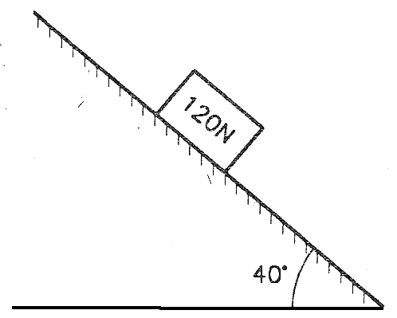
Fig.1

Q4: A block of weight W rest on an inclined plane and has attached to a string that runs over a pulley and carries the weight W at its other end as shown in fig. If the coefficient of friction between the block and inclined plane is 0.2 find the limiting value of the W’/W consistent with the equilibrium. Neglect friction in pulley. Assume α greater than angle of friction.
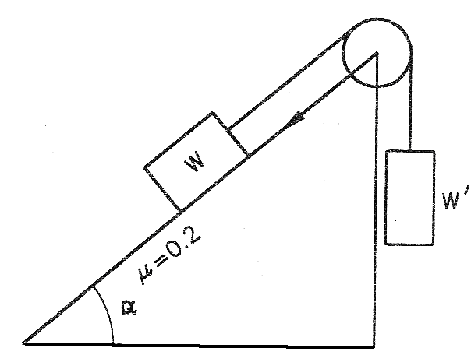
Fig.2

Q 5: A system consisting of two blocks connected by a cable is as shown in the Fig. The masses of the block A and block B are 7.5 kg and 25 kg respectively. Determine the magnitude of minimum force and it’s inclination with reference to the horizontal, to be applied on block B. The block has impending motion toward the right. Take the coefficient of friction at all contact surface to be 0.28.
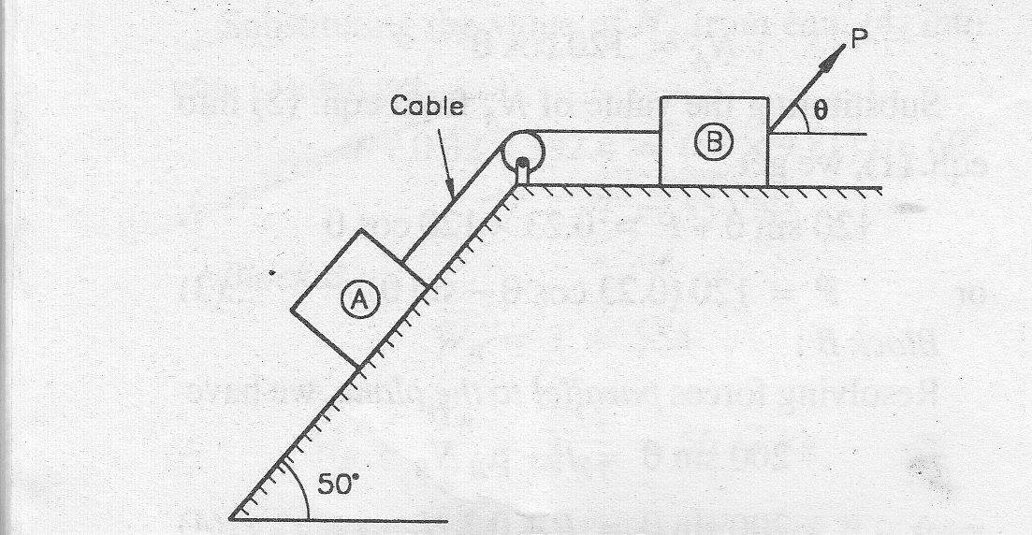
Fig 3

Q6: A block A Weighing W new tons is placed on a rough inclined plane having µ = 0.2 and is held in position by means of a horizontal rod hinged to the Block B which presses against a rough vertical wall having µ = 0.4 as shown in Fig. If the blocks B weights 500 N find the minimum value of W consist the equilibrium.
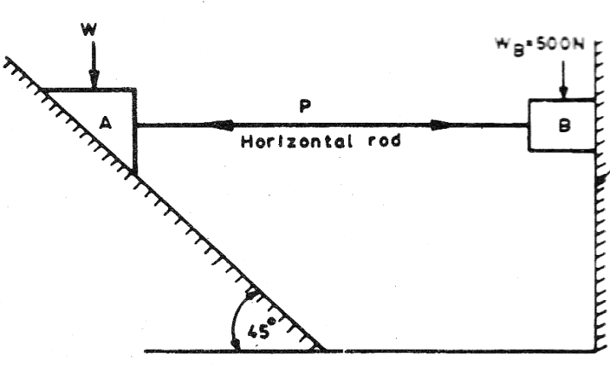
Fig 4
Q7: Two blocks A and B weighing 100 N and WB respectively are placed one over the other on the inclined plane making an angle of 40 ˚ with respect to the horizontal. The two blocks are connected by a string passed over a smooth pulley as shown in Fig. Determine the minimum weight of block B such that the lower block does not sleep down the place. Take M=0.22 at all contact surfaces.

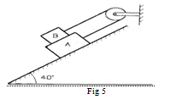

Q8: A cylinder of weight 100 N and radius 0.5 m and a rectangular block of weight 80 N are placed in contact on inclined plane with inclination of 30˚ with the horizontal as shown in fig 6.60. Find out the minimum force P required up the plane at the block to initialize an upward motion of the bodies, if the coefficient of friction is 0.60.
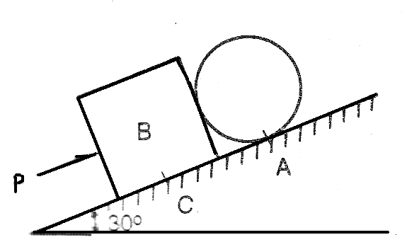
Fig 6
Q9: A ladder 5 m long and of 250 N weight in placed against a vertical wall in a position where its inclination to the vertical is 30˚. A man weighing 800 N climbs the ladder. At what position will he inclined slipping? The coefficient of friction for both the contact surface of the ladder, viz with the wall and the floor is 0.2.
Q10: A uniform ladder 3 m long weight 180 N. It is placed against a wall making an angle of 60˚ with floor. The coefficient of friction between the wall and the ladder is 0.25 and that between floor and ladder is 0.35. The ladder in addition to its own weight has to support a man weighing 900 N, at its top. Calculate:
The horizontal force P to be applied to the ladder at the floor level to prevent slipping.
If the force P is not applied what should be the minimum inclination of the ladder with the horizontal so that there is no slipping of it with the man at its top?

Q11: A system of two blocks connected by a string which passes over a pulley is shown in Fig. The coefficient of friction between block A and the plane and that between the belt and pulley is 0.3. Determine the minimum weight of block B required to keep the system in equilibrium condition.
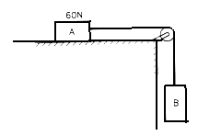
Fig 7
Q12: Determine the coefficient of friction between the rope and pulley for the impending motion of block A up the inclined plane as shown in Fig. The coefficient of friction between block A and the plane is 0.28.
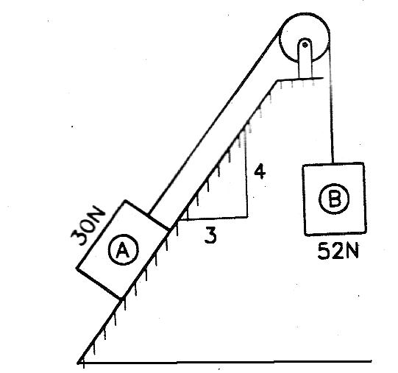
Fig 8
Q13: A wooden log weighing 23 KN is placed on an inclined plane, which makes an angle of 45˚ with reference to the horizontal. The rope connected to the wooden log is wound round a post as shown in Fig. Determine:
(i) Number of turns of rope required around the post for impending motion of the log down the plane, when a force of 0.24 KN is applied at the free end of the rope.
(ii) Force to be applied at the free end of the rope when impending motion of the log is to be up the inclined plane.
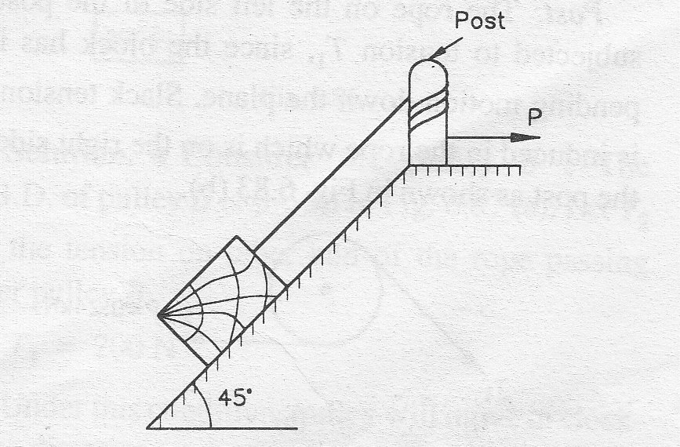
Fig 9

Q14: Determine the maximum force P required to be applied on wedge A to lift the wedge B shown in Fig. Take µ = 0.24 at all contact surface. Also find the support reaction

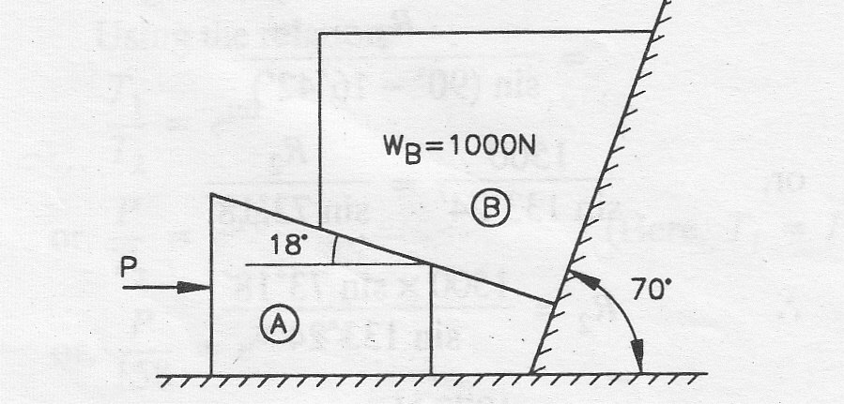
Fig 10
Q15: A block weighing 500 N is to be raised by means of a 15˚ wedge weighing 250 N as shown in Fig. Assuming coefficient of friction between all contact surface to be 0.2 determine what minimum horizontal force P should be applied to raise the block
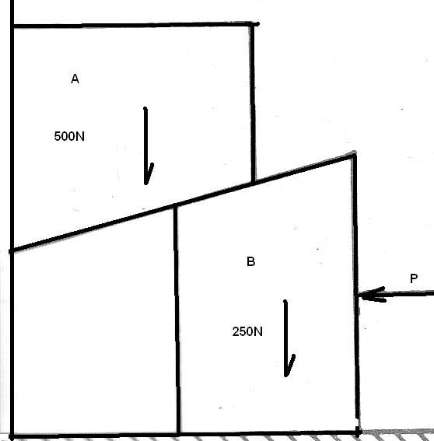
Fig 11

Unit: 3 and 4
WORK AND ENERGY
Q1. When a force is applied to a certain spring it gets stretched by 25mm. Calculate the work done, if the force required to stretch 1 mm of the spring is 20 N.
Q2. A Car weighing 8000 N accelerates from rest to a speed of 45 km/h in a distance of 50 m against a resistance of 100 N. Find the average driving force acting on the car. Using the average force, find the greatest power developed by the engine.
Q3. A mechanical device can lift a weight of 24 kN suspended by a heavy rope weighing 60 N per meter. If the length of the rope is 360 meter and it takes 30 seconds in winding up the loud to the top, find the power of the machine.
Q4. Water from a tank of capacity 18000 liters it to be lifted in 20 minutes by a pump through a height of 12 m. If the efficiency of the pump is 65 per cent, find the power of the pump.
Q5. A locomotive starts from rest and pulls a train weighing 10000 kN down an incline of 1 in 1000. The tractive resistance is 3 N/kN. If the constant engine pull is 50 kN, find the speed of the train after it has moved 2000 m. Find also the final power developed by the engine.
Q6. A 5 kg mass drops from 1.5 m upon a string whose modulus is 10 N/mm. What will be the speed of the block when the spring is compressed 60 mm?
Q7. A 45 N weight is dropped on a pan 450 mm below it. Pan is mounted on spring (spring constant 1800 N/m). Assume impact to be perfect plastic, weight of pan, W_{P} = 113 N as shown in Fig1. Determine:
(i) The velocity of the weight and pan immediately after impact.
(ii) The maximum compression of the spring where system comes to rest.
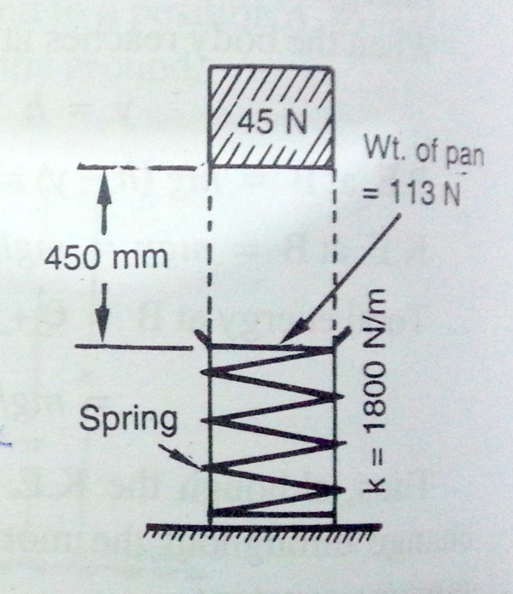
Figure-1
Q8. A block of weight 654 N is compressed against a spring as shown in Fig2. How far from ‘O’ will it strike on place at A? Take k = 4000 N/m and µ = 0.2.
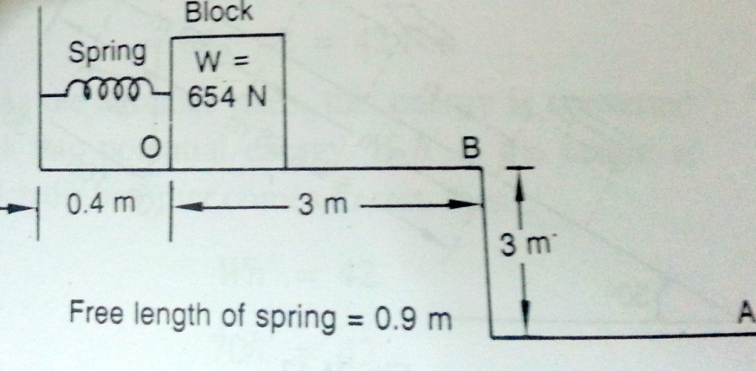
Figure-2
Q9. A bullet of mass 0.03 kg is fired horizontally into a body of mass 10 kg which is suspended by the string of 1 m length. Due to this impact, the body swings through an angle of 30˚with the vertical. Find the velocity of the bullet at impact.
Q10. At a mine, the end of a side track is to be provided with a spring bumper. The spring must be capable of stopping a 50 kN ore car which has a velocity of 3 m/s down the incline at a point 50 m up the incline from A, and then coasts from there to the bumper, as shown in Fig3 The track resistance remains constant at 400 N. what modules k must this spring have in order to stop the car after being compressed 0.6 m? What distance ‘s’ will the car roll back alone the level track after rebounding from the point of maximum compression ?
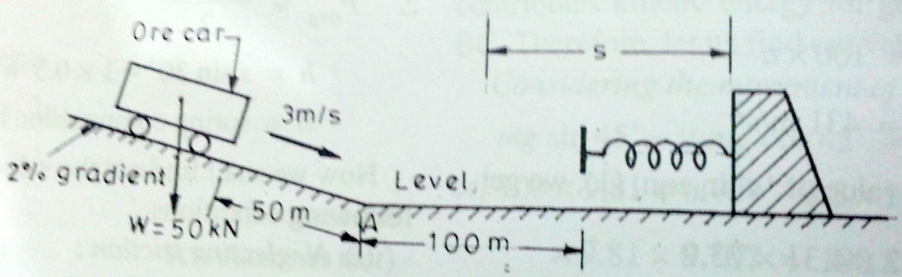
Figure-3
Q 11. Determine the magnitude of force P to be applied on the block A as shown in Fig4, such that the two blocks A and B cover a distance of 4 meter each to attain a velocity of 3.2 m/s. The coefficient of kinetic friction between block A and plane and that between block B and plane is 0.3.
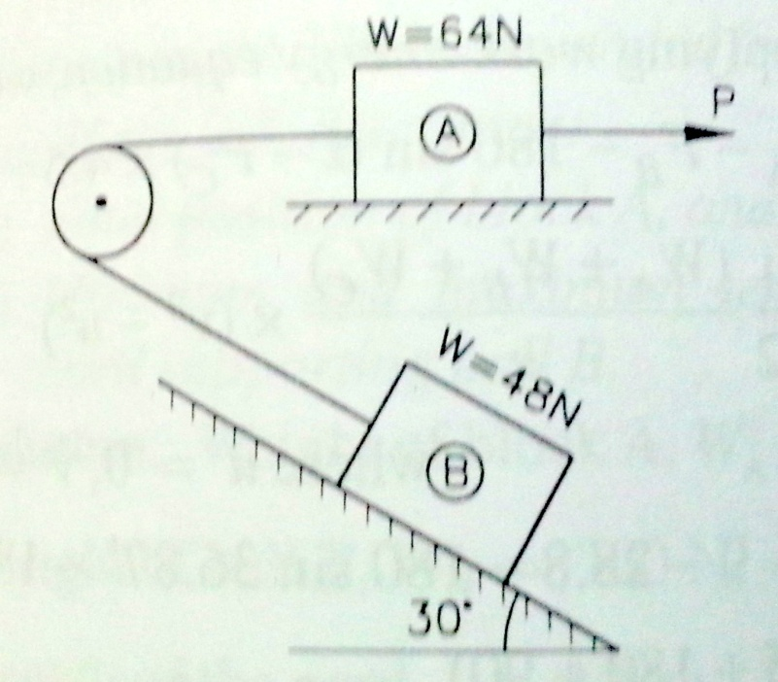
Figure-4
Q 12. A car shown in fig5 moving toward the bumper spring has a kinetic energy of 13.56 kNm. The main bumpers shield 1-1 is connected to the main spring which has a modulus of 0.21 kN/mm. The two auxiliary bumper shields 2-2 are 300mm behind 1-1 and are attached to secondary springs, each of which has a modulus of 0.105 kN/mm . Determine the greatest movement of 1-1. What percentage of energy will than be absorbed by the main spring?
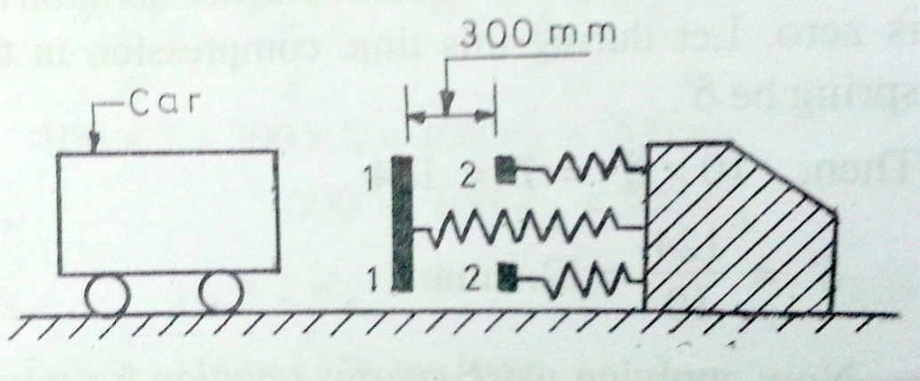
Figure-5

Unit: 3 and 4
COLLISION OF ELASTIC BODIES

Q1. A ball of mass 8 kg moving with a velocity of 10 m/s, impinges directly on another ball of mass 24 kg moving at a speed of 2 m/s in a opposite direction. If e=1/2, find the velocities of the balls after impact.

Q2. If two inelastic spheres have a direct impact, show that a kinetic energy lost by the impact is that of a body whose mass half the harmonic mean between the masses of the two impinging spheres and whose velocity is equal to their relative velocity before impact.

Q3. A ball of mass 2kgimpinges on a ball of mass 4 kg which is moving in the same direction as the first. If the co-efficient of restitution is ¾ and the first ball is reduced to rest after the impact, find the ratio between the velocities of the balls before the impact.

Q4. Three perfectly elastic balls A,B and C of masses 4kg,8kg and 16kg move in a same direction with a velocities of 8m/s,2m/s and 1.5m/s respectively. If the ball A impinges with a ball B, which in turn impinges with the ball C, prove that the ball A and B will be brought to rest by the impacts.

Q5. A ball of mass 4 kg moving with a velocity of 2 m/s impinges directly on another of mass 5kg moving with a velocity 1m/s in the opposite direction. If e=1/2, find the velocities of the balls after impact. Find also the loss of energy due to impact.

Q6. A ball impinges directly on a similar ball at rest. The first ball is reduced to rest by impact. Find the co-efficient of restitution, if half the initial kinetic energy is lost by impact.

Q7. A ball is dropped on horizontal floor from which it rebounds to a height of 8m. If the co-efficient of restitution between the floor and the ball is 0.7. Find the height from which the ball was dropped.

Q8. From what height, must a heavy elastic ball be dropped on a floor, So that after rebounding thrice it will reach a height of 9 meters?

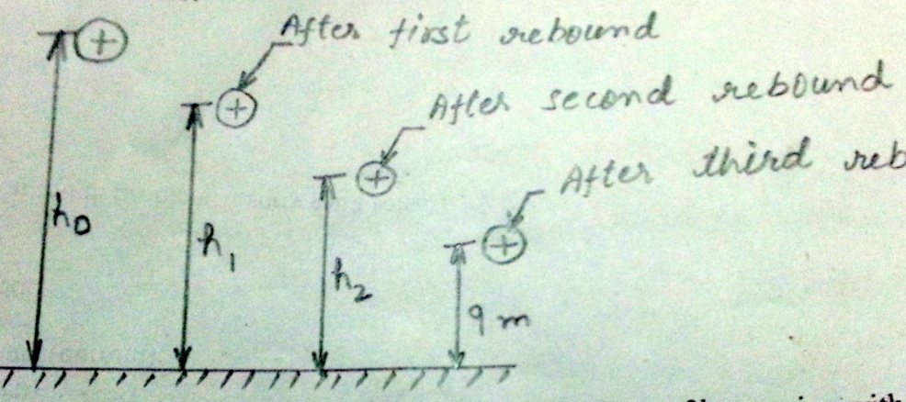

Q9. A ball of mass 3kg, moving with a velocity of 30m/s, Strikes a ball of mass 3kg moving with a velocity of 45m/s. At the instant of impact, the velocities of the balls are inclined at an angle 30 and 60 to the line joining their centers, as shown in fig. If the co-efficient of restitution is 0.9, Find

(i) The direction in which the first ball will move after impact.
(ii) Velocity of the first ball after impact.
(iii) The direction in which the second ball will move after impact.
(iv) Velocity of second ball after impact.
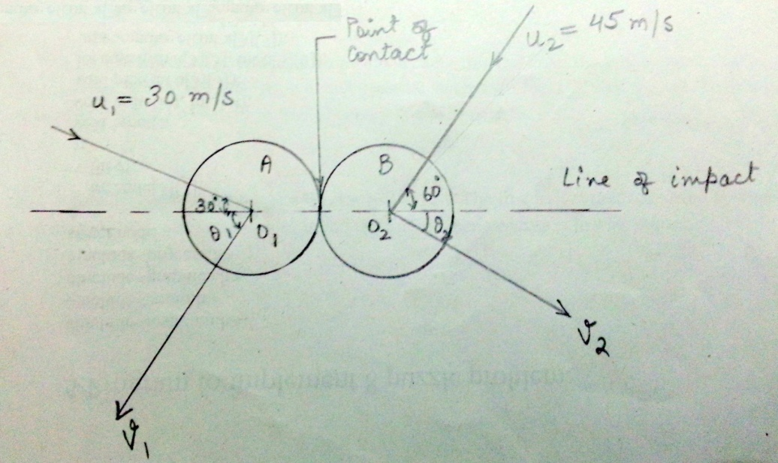

Unit: 3 and 4

Kinematics of Rigid Body

Q1.A car starting from rest reaches a velocity of 54 km/h in 30 seconds. Determine the angular velocity of the wheel of 600 mm diameter at t = 15 seconds.

Q2. A wheel rotating about a fixed axis at 30 rpm is uniformly accelerated for 70 seconds, during which time it makes 50 revolutions. Find the angular velocity at the end of this interval.

Q3.A wheel accelerates uniformly from rest to 1500 rpm in 15 seconds. What is the angular acceleration? How many revolutions does the wheel make in attaining the speed of 1500 rpm?

Q4. A wheel rotating about a fixed axis at 20 rpm is uniformly accelerated for 70 seconds during which time it makes 50 revolutions. Find:
- Angular velocity at the end of this interval
- Time required for the speed to reach 100 revolutions per minute.

Q5.A horizontal bar 1.5 m long and small cross section rotates about the vertical axis through one end. It accelerates uniformly from 1200 rpm to 1500 rpm in an interval of 5 seconds. What is the linear velocity at the beginning and the end of the interval? What are the normal and tangential components of the acceleration of the mid point of bar after 4 seconds after the acceleration begins?

Q6.In Fig.1 has shown a link LM, 6m long, the ends L & M of which are restrained to move in the horizontal and vertical guides. When the end L is 3m above O it moves at 4m/s.Determine (a) the velocity of the end M (b) The angular velocity of the link LM
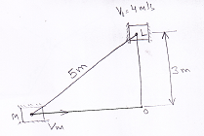
fig.1
Q7. The lengths of connecting rod and crank in a reciprocating pump are 1125 mm and 250 mm respectively. The crank is rotating at 420 rpm.Find the velocity with which piston will move, when the crank has turned through an angle of 40 deg from inner dead centre.
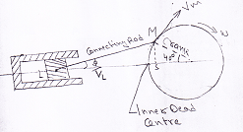
fig.2

Q8. For the mechanism shown in fig.3. Determine the linear velocity of N and angular velocity of link LN when the link MP is inclined 60 deg with the horizontal. Assume the link MP rotates at 350 rpm.
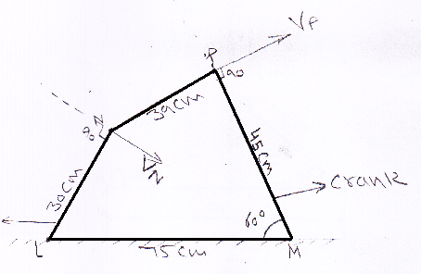
fig.3

Q9.An army vehicle traveling at 45 km/h has its wheels of 1m diameter. Find the velocity of the top of the wheel relative to a person.
- Sitting in the carriage, (ii) Standing on the ground.

Q10. A truck, having a wheel diameter of 1m, is moving at 36 km/h.The wheels of truck are rolling without slipping on the straight level surface. Determine (i) Velocities of the highest and the points on the wheel at any instant. (ii) The velocities of these points (highest and lowest) relative to a person seating in the truck and a person standing on the ground.

Q11. In a steam engine the lengths of the crank and connecting rod are 0.5m and 2m respectively. The crank is rotating at a uniform speed of 180 rpm in the clockwise direction. Determine the following when the crank has turned 45 deg from the inner dead centre. (i) Velocity of the piston (ii) Angular velocity of the connecting rod.

Q12. In a crank and connecting rod mechanism, the length of the crank and the connecting rod are 300mm and 1200mm respectively. The crank is rotating at 180 rpm.Find the velocity of the piston when the crank is at an angle of 45 deg with the horizontal.
Q13. In the quadratic crank mechanism as shown in fig.4. Determine the angular velocity of AD and the velocity of the point D for the phase indicated. Assume ωbc=10 rad/s
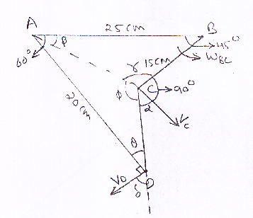
Fig.4

Unit: 3 and 4

Kinetics of Rigid Body

(Topics Covered: Kinetics of Particles: Eq of Motion, D’Alembert Principle)

Ques.1.An 80-kg block rests on a horizontal planeshown in figure 1. Find the magnitude of the force P required to give the block an acceleration of 2.5 m/s2 to the right. The coefficient of kinetic friction between the block and the plane is µk0.25.(P =535 N)
Ques.2.The two blocks are shown in figure 2, starting from rest. The horizontal plane and the pulley are frictionless, and the pulley is assumed to be of negligible mass. Determine the acceleration of each block and the tension in each cord.(aA =8.40 m/s2,aB=4.20 m/s2, T1 =840,T2=1680)
Figure (1) Figure (2)
Ques.3.A hockey player hits a puck so that it comes to rest in 9 s after sliding 30 m on the ice. Determine (a) the initial velocity of the puck, (b) the coefficient of friction between the puck and the ice.(6.67m/s,µk=0.0755).
Ques.4.A 20-kg package is at rest on an incline as shown in figure 3, when a force P is applied to it. Determine the magnitude of P if 10s are required for the package to travel 5 m up the incline. The static and kinetic coefficients of friction between the package and the incline are both equal to 0.3.(P=301 N)
Figure (3) Figure (4)

Ques.5. The two blocks shown are originally at rest as shown in figure 4. Neglecting the masses of the pulleys and the effect of friction in the pulleys and between block A and the horizontal surface, determine (a) the acceleration of each block, (b) the tension in the cable.(aA =2.49 m/s2,aB =0.831 m/s2,T =74.8N).

