GURU TEGH BAHADUR INSTITUTE OF TECHNOLOGY
G-8 AREA, RAJOURI GARDEN, NEW DELHI

ENGINEERING GRAPHICS 11
Assignment I
Section of solids

- A pentagonal prism of 35 mm long edges and 50mm long is resting on the H.P, such that axis is perpendicular to HP. One of the edge of the base is parallel to VP and 10mm away from VP. Pridm is cut by a section plane parallel to the V.Pand passing from 5mm in front of the axis.Draw its sectional front view and the top view.

- A hexagonal pyramid, base 35 mm side and axis 50 mm long, is lying on its base on the H.Pwith its axis perpendicular to the V.P. It is cut by a horizontal section plane, at a distance of 12 mm above the ground. Draw its front view and sectional top view.

- A pentagonal pyramid, base 30 mm side and axis 50 mm long has its base horizontal and an edge of the base parallel to the V.P.A section planeinclined at 30°to HP, cuts the axis at a distance of 25 mm above the base. Draw its front view and sectional top view.

- A cylinder of 40mm diameter, 50mm length and having its axis vertical,is cut by a section plane,perpendicular to the HP,inclined at 45° to the VP and intersecting the axis 32 mm above the base.Draw its front view,sectional top view.

- A cone of diameter 30mm and heigth 50mm is resting on the H.P. on its base is cut by a section plane parallel to the base at the heigth of 25mm from the ground. Draw the front view and sectional top view.

GURU TEGH BAHADUR INSTITUTE OF TECHNOLOGY
G-8 AREA, RAJOURI GARDEN, NEW DELHI

ENGINEERING GRAPHICS 11
Assignment II
Orthographic Projection

- A ‘L-shaped’ solid object having dimensions of length (L = 50mm),width (W= 40mm) and height (H =30mm). Assuming that this object is lying in the first quadrant. Draw it's front view, top view, and side view.

- Draw the orthographic projection (top, front, and side view) of the object as shown in figure in third angle.
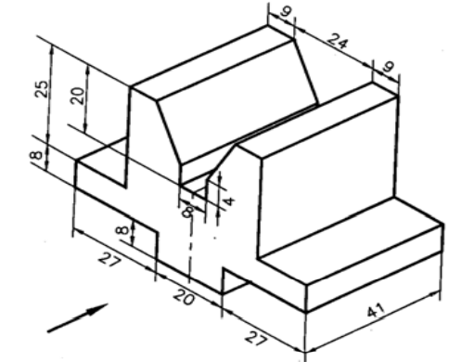

- Draw the orthographic projection (top, front, and side view) of the object as shown in figure in first angle.
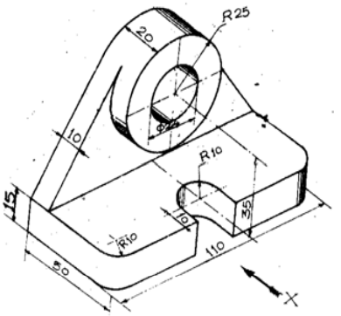

- Draw the orthographic projection (top, front, and side view) of the object as shown in figure in third angle.
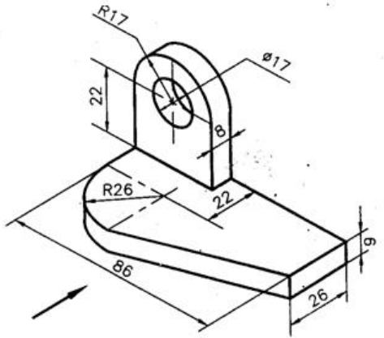

GURU TEGH BAHADUR INSTITUTE OF TECHNOLOGY
G-8 AREA, RAJOURI GARDEN, NEW DELHI

ENGINEERING GRAPHICS 11
Assignment III
Isometric Projection

- Draw the isometric projection of the cube,cylinder and cone.
(a)Size of cube 20mm*20mm*20mm.
(b) Diameter of cylinder 30mm and axis 50mm.
(c) Diameter of cone 30mm and axis 50mm.

- A pentagonal pyramid of side 30mm and axis length 70mm is lying on HP such that axis is perpendicular to HP and parallel to VP as shown in figure. Draw the isometric projection.
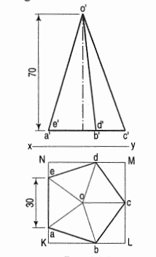
- A cube of 30mm edges is palced centrally on the top of a cylindrical block of 52 mm diamerer and 45mm height. Draw the isometric view the solid.
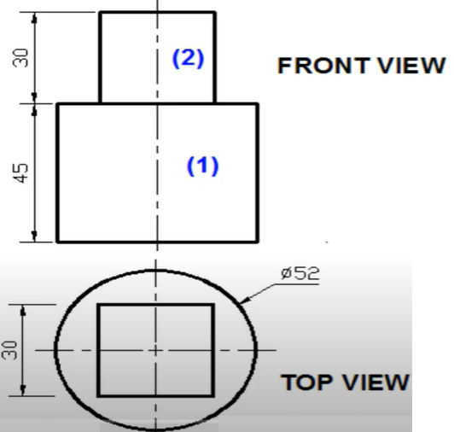

- The front and top view of the model of steps are shown in figure.Draw the isometric view.

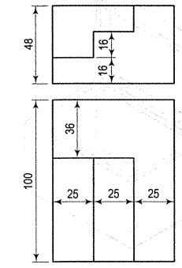

GURU TEGH BAHADUR INSTITUTE OF TECHNOLOGY
G-8 AREA, RAJOURI GARDEN, NEW DELHI

ENGINEERING GRAPHICS 11
Assignment IV
Oblique Projection

- Draw the oblique projection of circle of diameter 30mm using offset method and four centre approximate method.

- A frustum of a square pyramid has its base 30 mm, top 20 mm, side and height 40 mm. Draw the oblique projection of the pyramid when it rests on its base on the H.P. with one of the sides of the base perpendicular to the V.P.

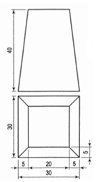

- A cylinder of diameter of base 40 mm and height 50 mm rests with its base on the H.P. Draw the oblique projection using the cavalier method.

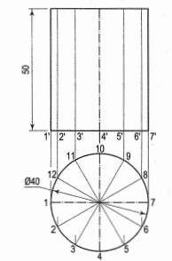

- A hexagonal prism, base 50 mm side and axis 100 mm long, resting on its base on H.P. is cut by a section plane perpendicular to V.P. and makes the angle of 45° with the H.P., passes through a point on the axis 20 mm from it's top. Draw the oblique projection of the prism by the cavalier method with receding axis inclined at 45° with the horizontal when, (a) Two rectangular faces of the prism are equally inclined with V.P. (b) One rectangular face of the prism is parallel to V.P.

