Guru Tegh Bahadur Institute of Technology
First Semester
Electrical Science (ES – 107)
Assignment – 1
Review of Electrical Science Fundamentals

- Write the units and dimensions of the following physical quantities:
  - Force b. Power c. Electric field intensity d. Electric flux density e. Resistance f. Capacitance g. Inductance h. Resistivity
- Illustrate color coding of resistors with figures/table.
- A resistor is marked as follows: 1st band – brown, 2nd band – black, 3rd band – orange, no other band. Find the resistance and its range.
- A voltage of 20V is required to cause a current of 2A to flow in a resistor of resistance 10Ω. What voltage would be required to make current flow if the resistance was 40Ω.
- A body of true weight 10N appears to weigh 9N when its weight is measured by meAnsof spring balance in a moving lift.What is the acceleration of the moving lift at the time of weighing?
- Define electromotive force and differentiate it from potential difference.
- Define temperature coefficient of resistance.
- When a potential difference of 10V is applied to a coil of Copper wire at temperature of 20ºC, current of 1A flows in the coil. After some time, the current falls to 0.95A, yet the emf remains unaltered. Determine the increased temperature of coil given that the temperature coefficient of resistance of copper is 4.28*10⁻³/ºC.

Answers:
- 10kΩ, 8kΩ - 12kΩ
- 80V
- 0.98ms⁻², downwards
8. 33.4ºC

Guru Tegh Bahadur Institute of Technology
First Semester
Electrical Science (ES – 107)
Assignment – 2
Review of Circuit Fundamentals

- Determine I₁ and I₂ for Fig.1.
- Find V₁ and E₂ for Fig. 2.
- For the given circuit in Fig 3, find R such that I=1.5A with E = 20V using conductance method. Ans:R = 6Ω
- Find equivalent resistance between A and F for Fig 4. Ans:R_{AF} = 5/6Ω
- For Fig 5, Find V which produces a current of 0.25A in the 3Ω resistor. Ans:V = 20V.

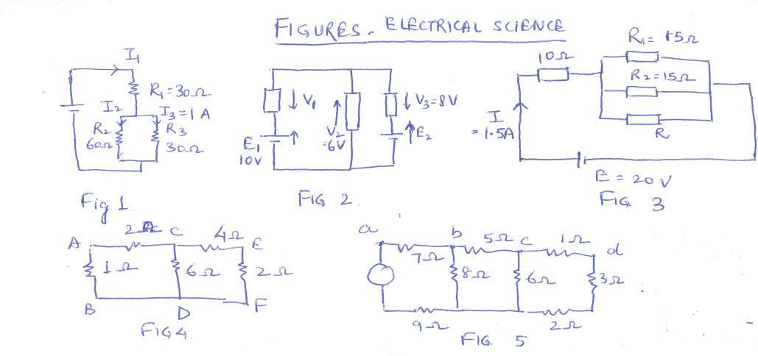

Guru Tegh Bahadur Institute of Technology
First Semester
Electrical Science (ES – 107)
Assignment – 3
Mesh and Nodal Analysis, Thevenin’s/Norton’s Theorem, and
Superposition Theorem
- Find V_{CE} and V_{AG} in Fig. 6, using mesh analysis. Ans:V_{CE} = -5V and V_{AG} = 30V.
- Determine current in 5Ω resistor in Fig. 7, by mesh analysis. Ans:
- Use nodal analysis to find voltage across 5Ω resistance and current in the 12V source, in Fig. 8. Ans:
- Find branch currents using nodal analysis in Fig. 9. Ans:7/9A, 1/3A, 13/12A, 17/12A
- Find i using nodal analysis in Fig. 10. Ans:2A
- Find I_{AB} using superposition theorem in Fig. 11.
- Find I_{3Ω} using Thevenin’s theorem in Fig. 12. Ans:1A
- Find Thevenin’s equivalent between A and B in Fig. 13. Ans:V_{AB}=5V, R_{th}=5Ω
- Find Norton’s equivalent circuit for Fig. 14. Ans:2A, 16Ω
- Find current through 25Ω resistance using superposition theorem in Fig. 15. Ans:1/5A
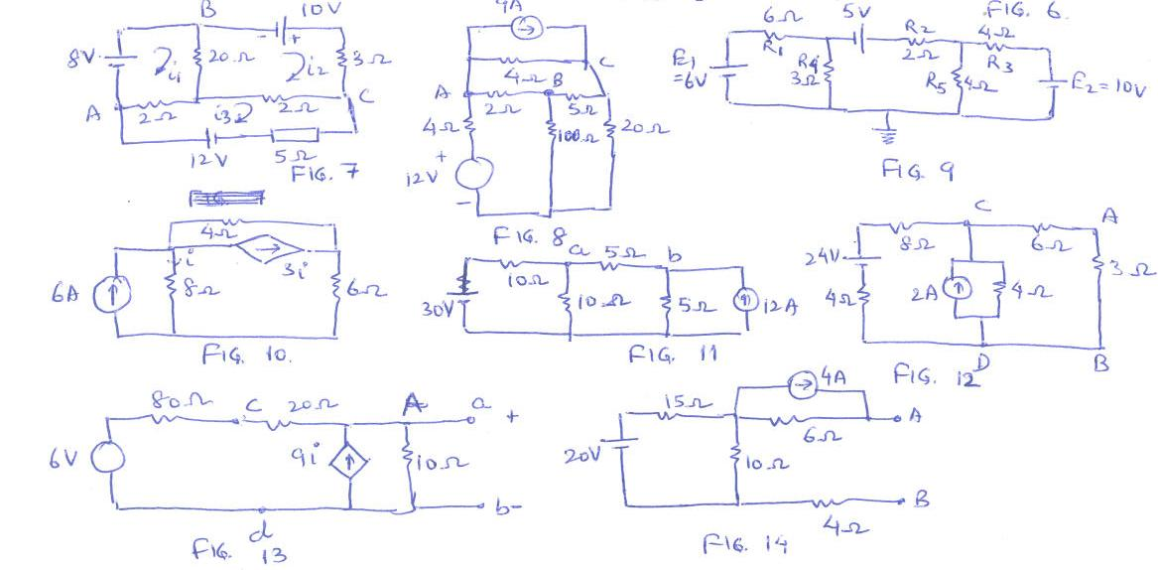
Guru Tegh Bahadur Institute of Technology
First Semester
Electrical Science (ES – 107)
Assignment – 4
AC Fundamentals – Series, Parallel circuits and Complex Power

- An alternating voltage has equation v =141.4 sin 377t, what are the values of rms voltage, frequency and instantaneous voltage when t=3ms. Ans:127.8V
- Calculate form factor for the waveforms in Fig. 16. Ans:1.0 and 3.16.
- A coil having R=12Ω, L=0.1H is connected across 100V, 50Hz supply. Calculate:
  - X_{L} and Z of the coil Ans:X_{L} = 31.4Ω, Z=33.6Ω
  - Current in the coil Ans:I=2.97A
  - Phase difference between voltage and current Ans:69⁰.
- A circuit has R=12Ω, L=0.15H, C=100µF in series, connected across 100V, 50Hz supply. Calculate
  - Current in each branch Ans:I_{R}=2A, I_{L}=2.12A, I_{C}=3.14A, I=2.24A
  - Supply current Ans:I=2.24A
  - Phase angle between supply current and voltage Ans:0.893 radian
- An inductor coil is connected in series with a pure resistor of 30Ω across a 230V, 50Hz supply. The voltage measured across the coil is 180V and across the resistor is 130V. Find power dissipated in the coil. Cosϕ =0.077, P=60W.
- Briefly explain significance of power factor.
- A network is arranged as shown in Fig. 17. Calculate the value of current in each branch and its phase relative to the supply voltage. Draw complete phasor diagram. Ans:I=10.4A, angle 44⁰, I_{A}=8.24A, angle 73⁰, I_{B}=5.18A, angle -7.16⁰.
- Calculate active and reactive power if V=100+j200V, I=10+j5A, Ans:2000W, 1500VAr
- A resistance R=10Ω and inductive reactance X_{L}=5Ω are connected in series across 100V, 50Hz supply. Find Z, I, pf, P, Q, apparent power and complex power.
Z=10+j5Ω (11.8Ω, angle 26.56⁰)
I=8-j4A
Pf=0.894 lag
P=800W, Q=400VAr, S=894VA, complex power = (800+j400) VA
- Impedances of two parallel branches are (20+j15Ω) and (10-j60)Ω. If supply frequency is 50Hz, find resistance and inductance/capacitance in each branch. Also derive a complex expression for admittance of the combined network, and therefore find the phase angle between applied voltage and resultant current. State whether the current is leading or lagging with respect to supply voltage.
Ans:20Ω, 47.8mH, 10Ω, 53 µF, (0.0347 – j0.0078)S, 12.6⁰ lag
- An alternating emf of 100V is induced in a coil of impedance 10+j25Ω. To the terminals of this coil is joined a circuit consisting of two parallel impedances 30-j20Ω and other of 50+j0Ω. Calculate the current in the coil in magnitude and phase with respect to the induced voltage.
Ans:2.83A, 30⁰lag.

Guru Tegh Bahadur Institute of Technology
First Semester
Electrical Science (ES – 107)
Assignment – 5
Transformer and Rotating Machines

- Illustrate working principle of transformer in brief and draw phasor diagram for transformer on no load and full load.
- A single phase transformer has 1000turns on the primary and 200turns on the secondary. The no-load current is 3A at a pf 0.2lag when the secondary current is 280A at a pf of 0.8lag. Calculate the primary current and pf. Assume negligible voltage drop in windings. Ans58.3A, 38.8⁰.
- Define voltage regulation for a transformer. A 100kVA transformer has 400turns on the primary and 80turns on the secondary. The primary and secondary resistances are 0.3Ω and 0.01Ω, and the leakage reactances are 1.1Ω and 0.035Ω respectively. The supply voltage is 2200V. Calculate
    - Equivalent impedance referred to the primary circuit
    - Voltage regulation and secondary terminal voltage for full load having a pf of
      - 0.8lag
      - 0.8lead
Ans:R_{e}=0.55Ω, X_{e}=1.975Ω, Z_{e}=2.05Ω,
(1)3.36%, 425V (2)-1.54%,447V
- List five applications of three phase induction motor.
- Draw schematic diagram of a 4-pole DC machine. Explain armature reaction in brief.

Guru Tegh Bahadur Institute of Technology
First Semester
Electrical Science (ES – 107)
Assignment – 6

Ques 1 What is inductance, resistance and capacitance? Make a comparative table to explain these properties.

Ques 2. Explain the phenomenon of electric current transformation from one point to another.

Ques3. Define in detail and explain Kirchoff’s current and voltage law. Also give a suitable example for each.

Ques 4. Find Equivalent star conversion.
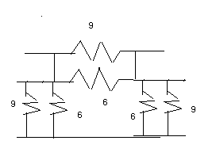
Ques5. Calculate power loss in 1 ohm resistor
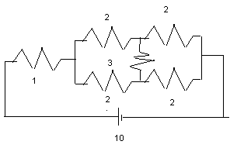

Ques 6. Find current in all branches
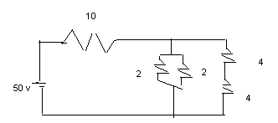

Guru Tegh Bahadur Institute of Technology
First Semester
Electrical Science (ES – 107)
ADDITIONAL REFERENCES FOR STUDY MATERIAL
Books
- Hambley, “Electrical Engineering Principles”, Tata McGraw Hill
- Edward Hughes, “Electrical and Electronic Technology”, Pearson Education
- Cathey and Nasar, Basic Electrical Engineering

URLs
- www.nptel.com

