ASSIGNMENT 1
Digital Communication
UNIT I
1. What do you mean by line codes? What factors decide the selection of appropriate line code for a specific application?
2. Discuss High Density Bipolar (HDB) signaling line code. Give some practical examples for the same.
3. State Shannon Hartley Capacity Theorem.
4. Draw the different Line Code Waveforms for the data ‘ 0011 0110’
a. NRZ bipolar code
b. RZ unipolar
c. AMI
d. HDB3
5. What is error in flap top sampling? How is it reduced?
6. Explain difference between DM and ADM systems in brief.
7. What is Quantization error? How does it depend on step size?
8. Find out expression for signal /Quantization noise ratio for sinusoidal modulating signal?
non-uniform quantization. Why it is required. Explain -law and A-law Companding?
9. Write briefly on:
a) Aliasing and anti-aliasing
b) Apperture effect
10. What is Slope overload distortion and granular noise ?

ASSIGNMENT 2
Digital Communication
UNIT II
1. (a) Discuss Optimum Receiver Algorithm. Justify that the data resulting from its implementation is always optimum.
(b) A binary communication channel has the following proiri probabilities P(m0) = 0.6, P(m1) = 0.4, P(r0/m0) = 0.8, P(r1/m0) = 0.2, P(r0/m1) = 0.4 and P(r1/m1) = 0.6. Apply Optimum Receiver Algorithm.
2. What is a random variable? Elaborate the types of random variables with example.
3. What is ‘ENSEMBLE’? Explain the concept with the help of a practical Example.
4. What is the difference between stationary and non stationary stochastic process? Noise signal is a non stationary random process. State true or False and Justify your answer.
5. Why statistical averages are important in information theory?
6. Binary data are transmitted over a noisy channel in a block of 16 binary digits. The probability that a received digit is in error due to channel noise is 0.01. Assume that the error occurring in various digit positions within a block are independent. Find the average number of errors per block.
7. What is an ergodic process? Explain in detail.
8. Consider a sinusoidal process X(t) denoted by
X(t) = Acos(2 π ft +θ)
Where A, f are constant and θ is uniformly distributed random variable
f(θ) = {½ , 0 ≤ θ ≤2π and 0 elsewhere}.
Show that process is ergodic in both mean and autocorrelation function.
9. Discuss the physical significance of PSD. Also explain its different properties.

10. What properties of a random process make it a Gaussian Process? Why it is an important process type in communication system analysis?

ASSIGNMENT 3
Digital Communication
UNIT III
Let us examine the sampled matched filter and whitened matched filter models in an example case where the channel impulse response is g(t)=δ(t )+0.2δ(t-T). (Such a symbol-spaced channel model is, of course, a very special case, and one has to be carefull with the generality of the conclusions drawn from this example). Assume further that a root raised cosine filter hRRC(t) is used as the transmit filter. The channel noise is assumed to be white with power spectral density N0
o What is the matched filter in this case?
o What is the continuous time overall response (transmit filter – channel - matched
filter)?
o What is the overall system impulse response with sampled matched filter?
o What is the noise power spectral density at the matched filter output?
o What is the noise power spectral density at the sampled matched filter output?
o What is the transfer function of the noise whitening filter?
o What is the overall system impulse response with whitened matched filter?

ASSIGNMENT 4
Digital Communication
UNIT IV
- 1: Write a formula, in the style of the baseband signal set, for the transmitted signal as shown in the plot of the baseband signal set that emerges when we use this modulated signal.
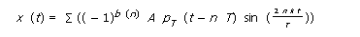
- PROBLEM 2: Show that indeed the first and third harmonics contain 90% of the transmitted power. If the receiver uses a front-end filter of bandwidth (3/2Ѓ)
what is the total harmonic distortion of the received signal?

- PROBLEM 3: What are the considerations in choice of digital modulation schemes?

- PROBLEM 4: Draw the BPSK waveform of the given data sequence
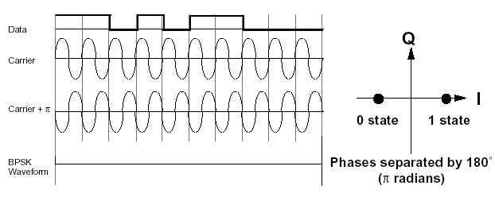

- PROBLEM 5: Draw the BFSK waveform of the given data sequence

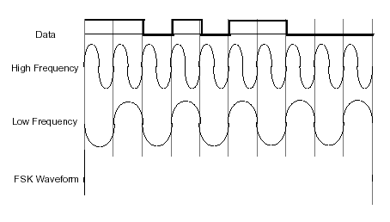

PROBLEM 7: Given the In-phase and quadrature phase components, draw the resultant QPSK waveform.
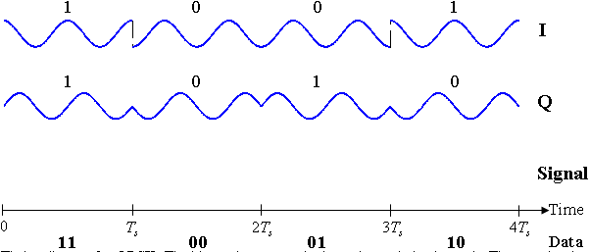

PROBLEM 8: Given the In-phase and quadrature phase components, draw the resultant OQPSK waveform.

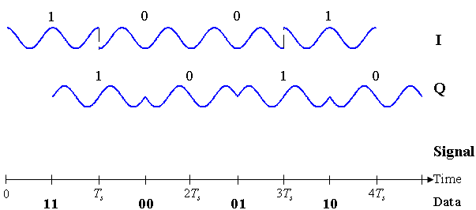

PROBLEM 9: Draw the QPSK waveform

